# Getting Started With Amazon AWS for Server and Database Hosting in Education

Joshua B. Gross

Last Revision: June 19, 2015



This document contains instructions to set up and connect to a database instance running the MySQL software and a server instance running Linux on Amazon AWS (Amazon Web Services). It uses some of the AWS site documentation, but hopefully offers some additional help to make setup easier. This is for academic/educational purposes; the configuration is grossly insecure for any professional operation or data that is sensitive or private.

This document is only a draft; any problems you encounter should be sent to the author, Joshua Gross, at [gross.joshua.b@gmail.com](mailto:gross.joshua.b@gmail.com). At the time of writing, AWS offers 12 months of free services, and this document is designed to show how to use those free services, but they could become pay services either through an error on the part of the author or because Amazon changes something. If you encounter any requirement to pay for any of these services, please inform Joshua Gross ASAP.

This document does not describe how to create/activate an AWS account; that is beyond the scope, and must be done before any steps described herein are taken. In other words, go create an AWS account before starting this. This page has an instructional video and a link to create an account <https://aws.amazon.com/getting-started/?nc2=h_l2_cc>.

This document is released under the Creative Commons Attribution-ShareAlike 4.0 International License, which means you may redistribute this document as long as you attribute authorship to Joshua Gross, you may create and share adaptations of this work as long as you allow others to create and share adaptations of your adaptations, and you may use the document for commercial purposes. As noted above, some of the content in this document comes from AWS site documentation, and is used here under Fair Use doctrine. One of the last steps is to build several databases from scripts; those scripts will hopefully be distributed with this document.

Step One: Installing Software and Configuring Access to AWS

1. Go to the AWS IAM (Identity and Access Manager) and select Users

<https://console.aws.amazon.com/iam/home#users>

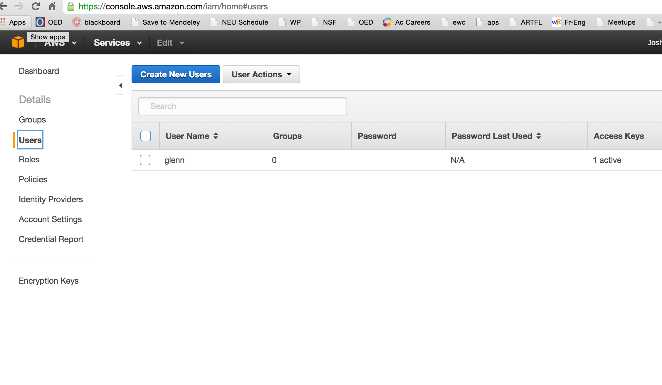

1. Create a new user, enter a user name, and select the “Create” button on the bottom right.

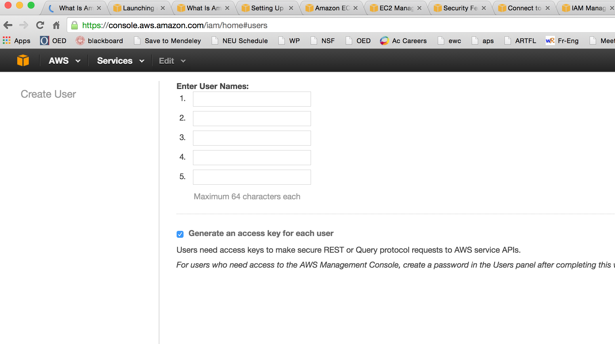

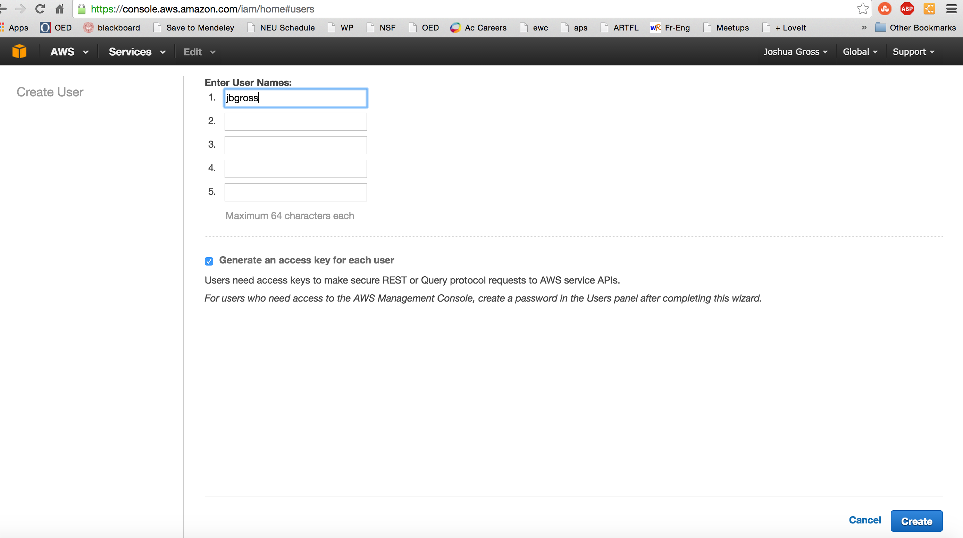

1. Download the security credentials for this user by selecting the “Download Credentials” button on the bottom right. Note the name of the file and where it downloads to (it should be called credentials.csv and will download to your preset downloads folder.

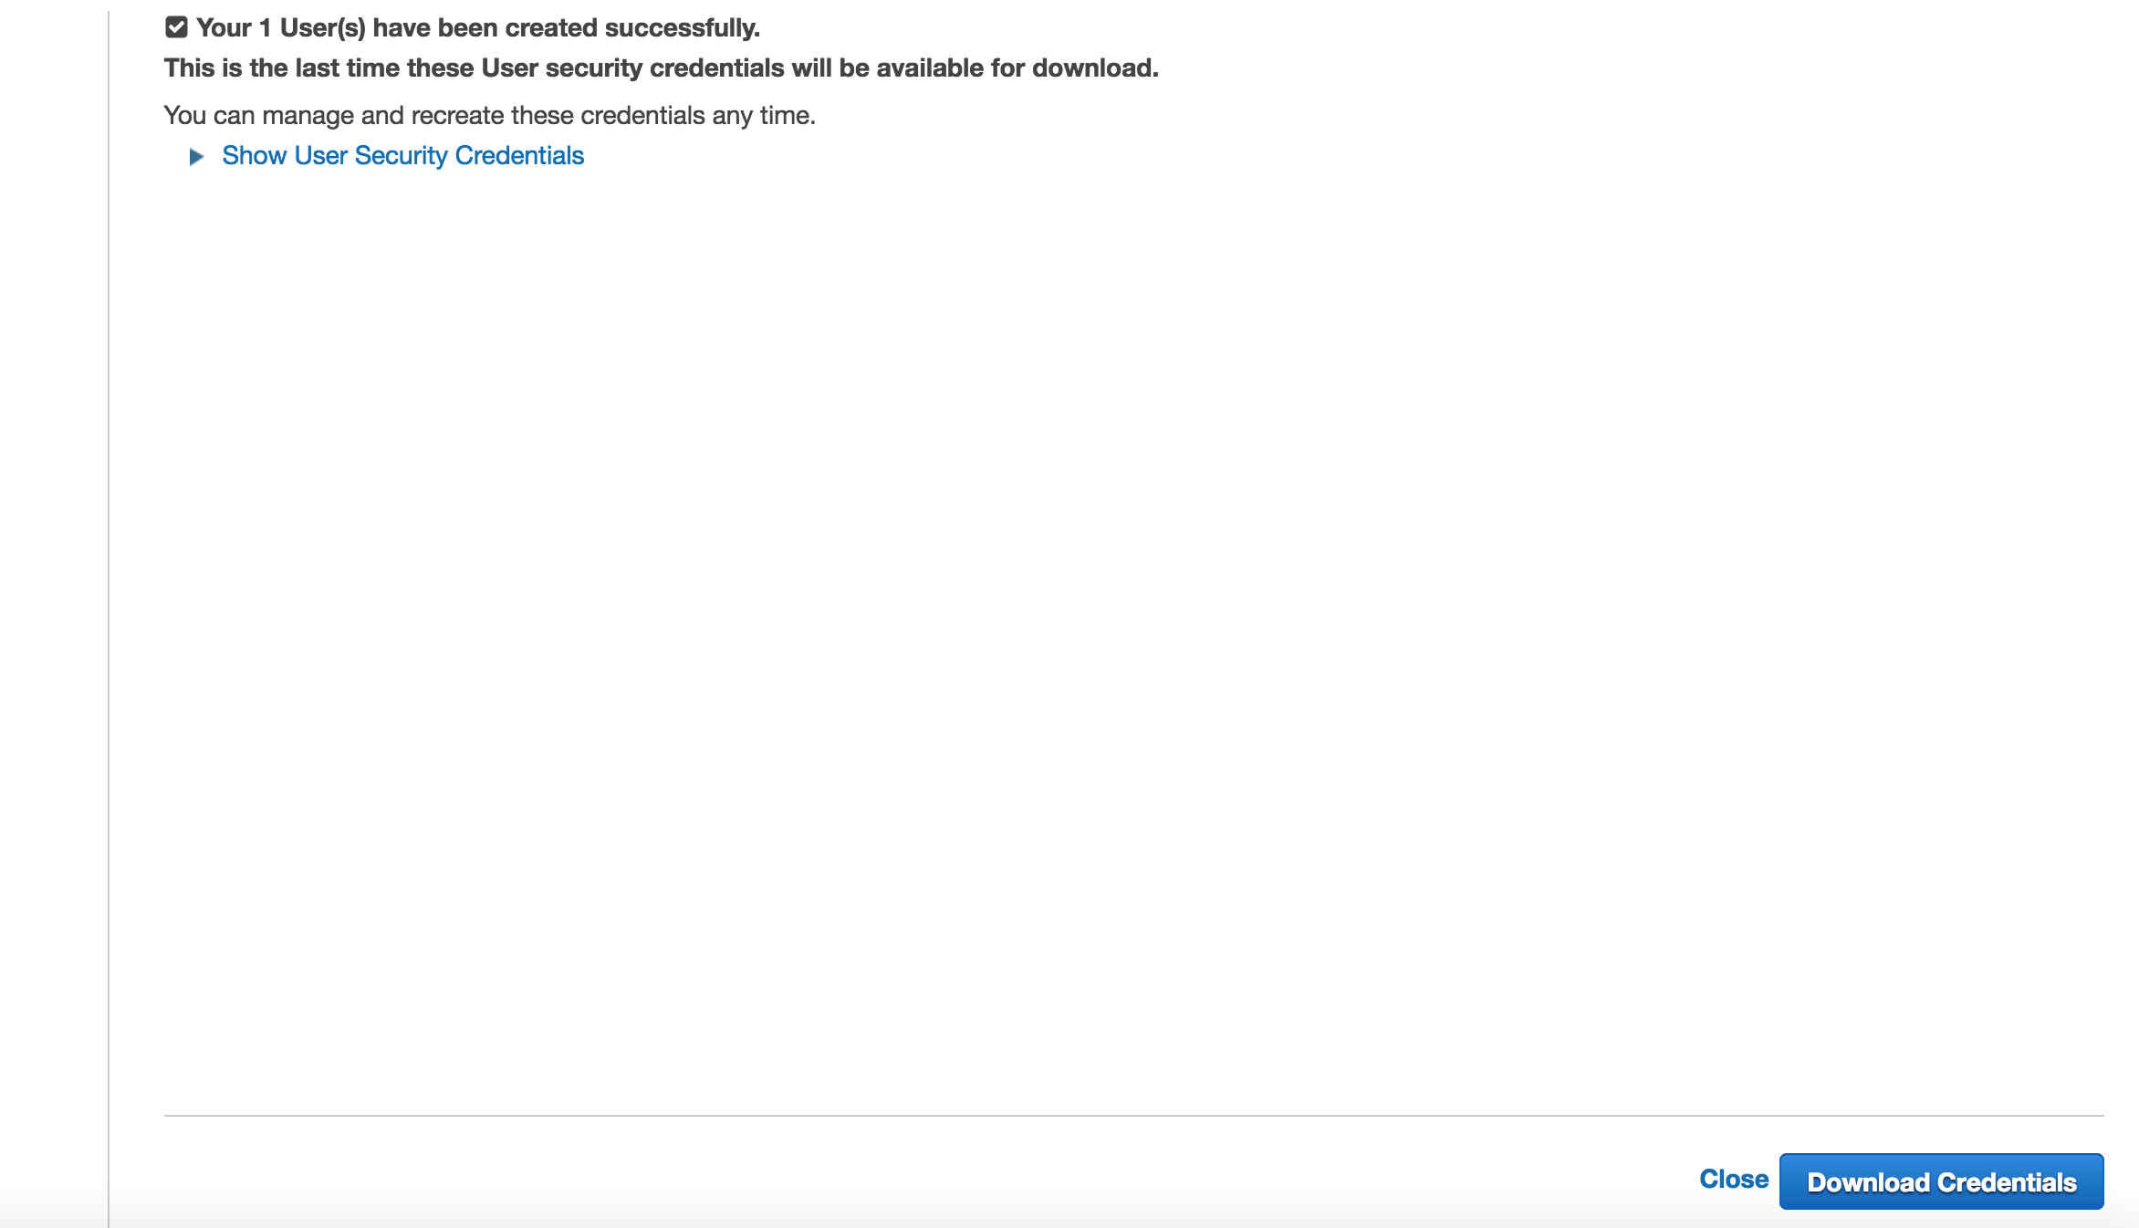

1. Select “Close” once you have downloaded the file.
2. Select “Policies” on the left toolbar: <https://console.aws.amazon.com/iam/home#policies>

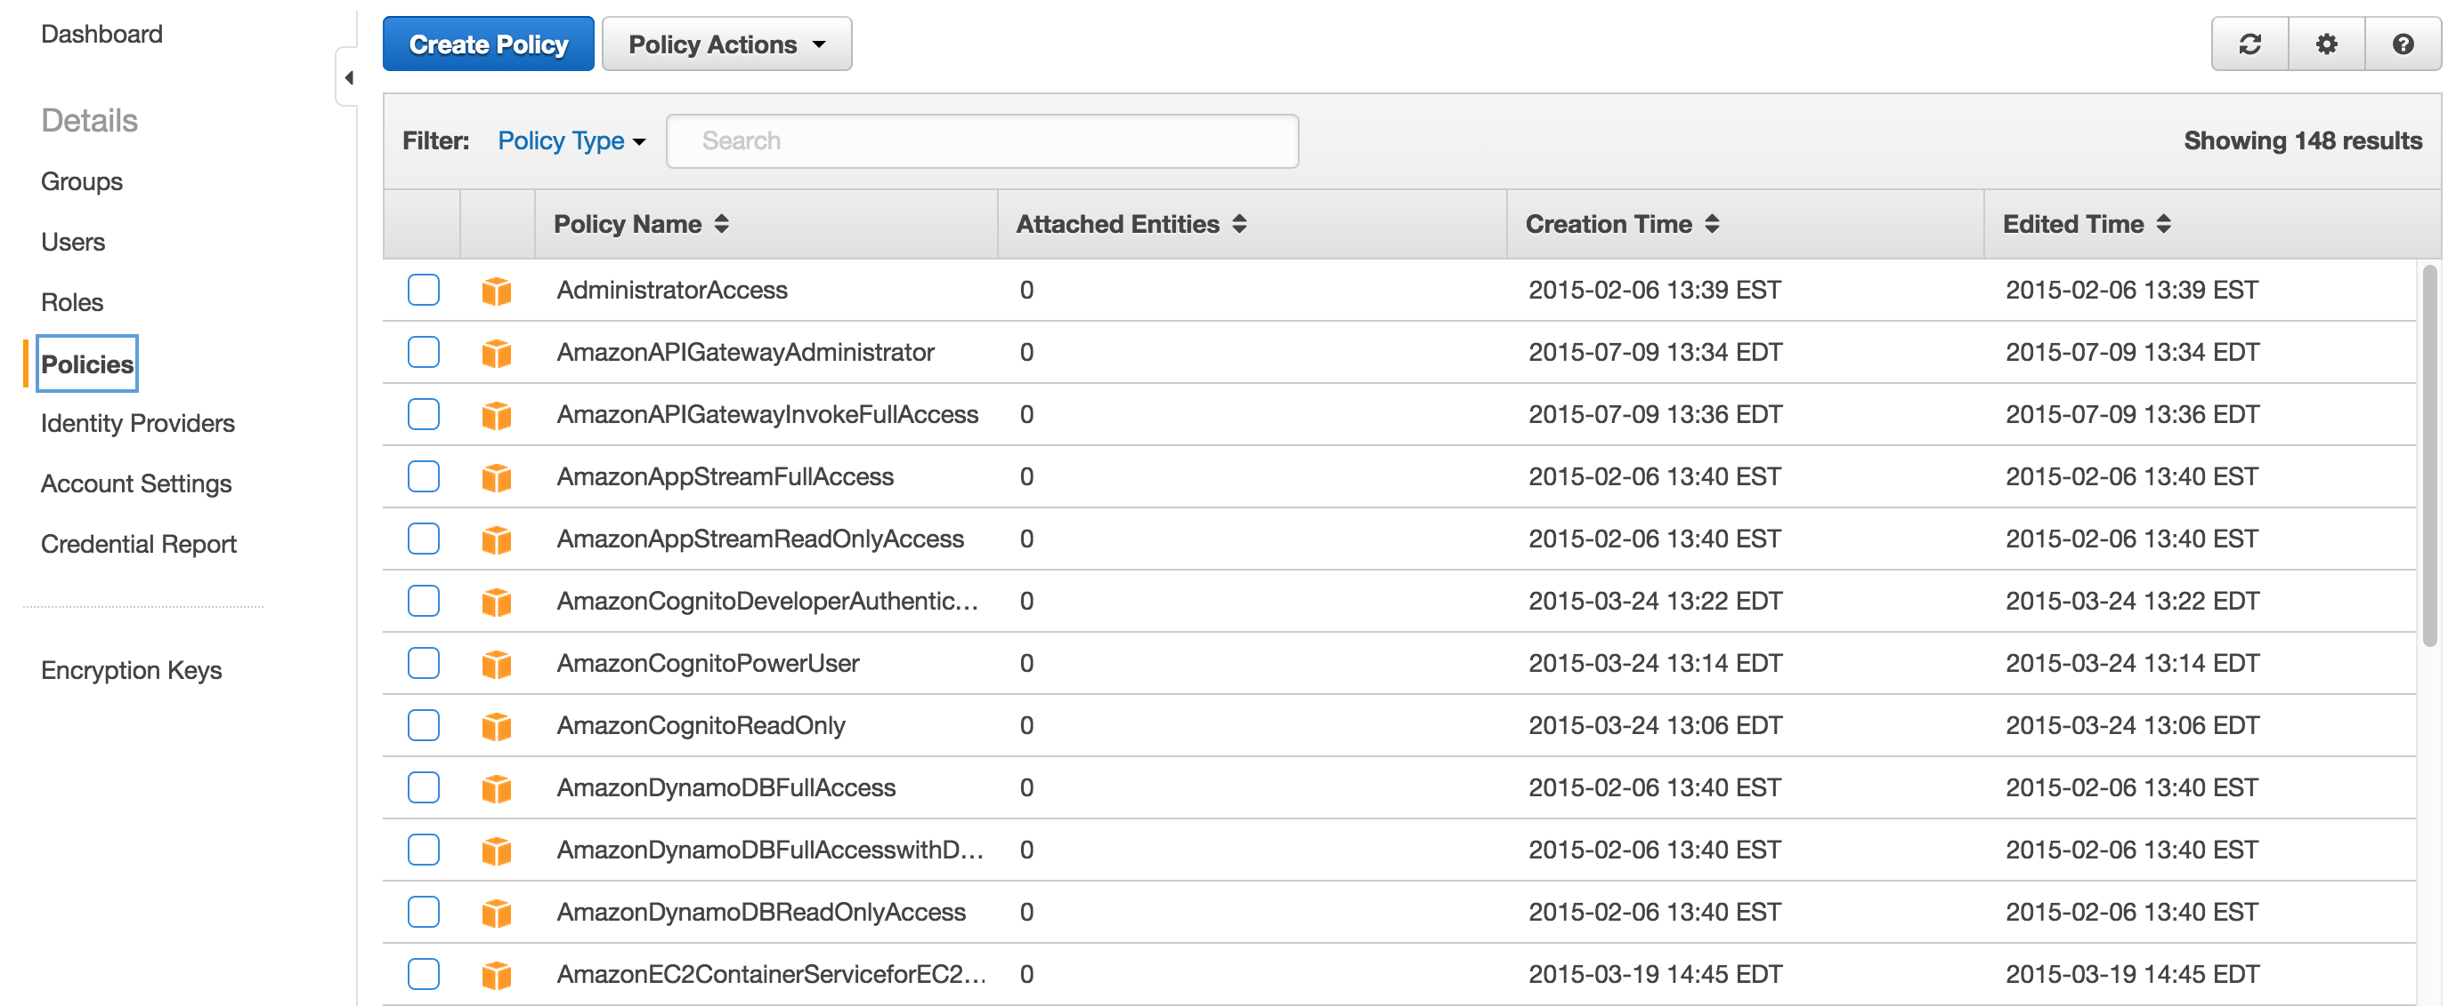

1. Select the “Create Policy” button

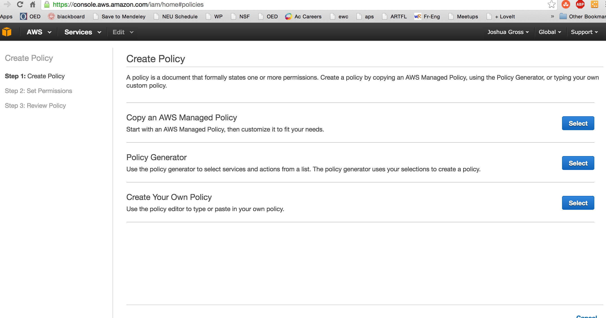

1. Select the “Select” button for “Copy an AWS Managed Policy”

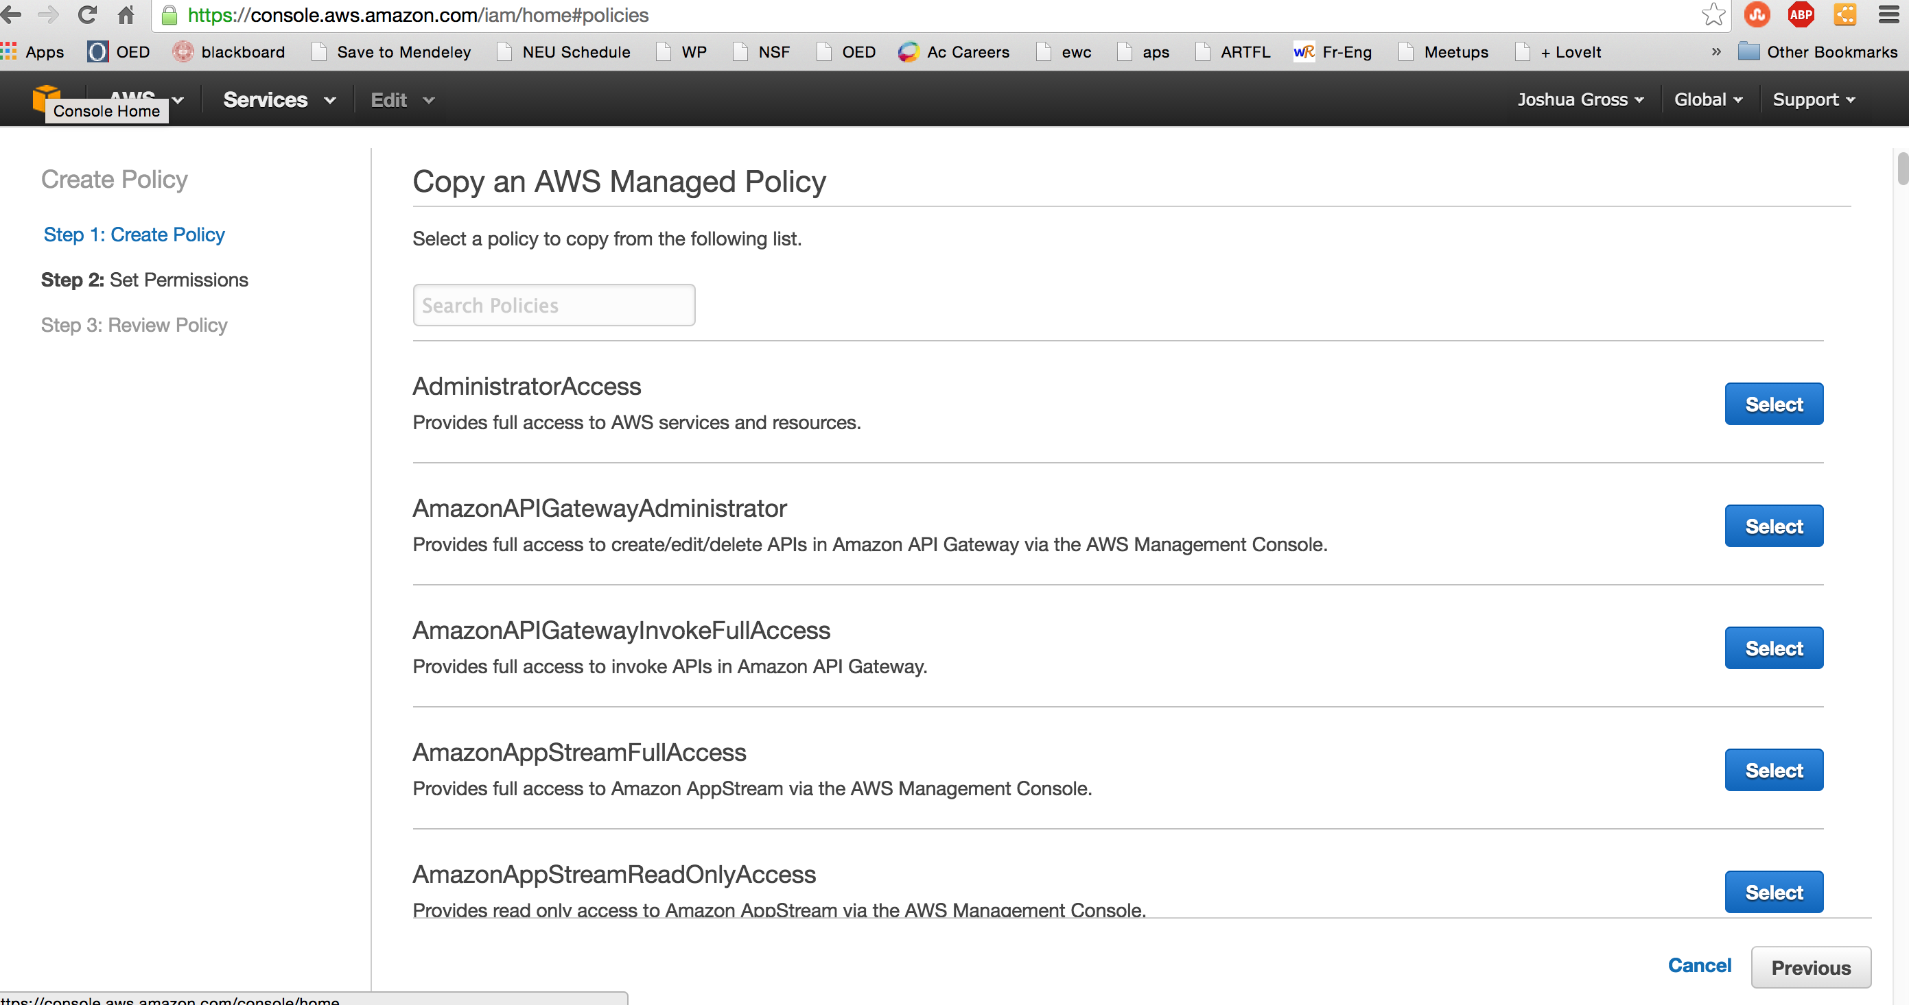

1. Select the “Select” button for “AdministratorAccess”

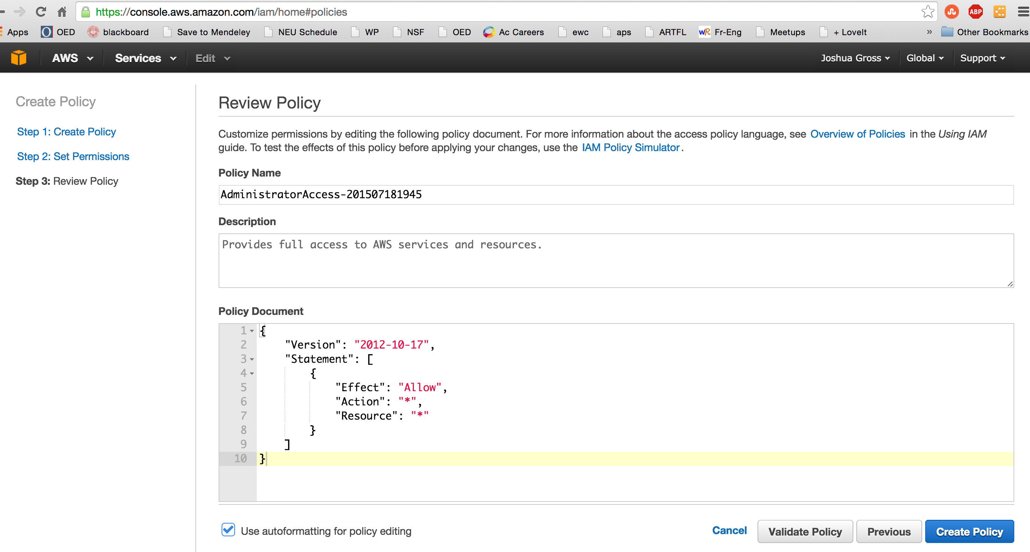

1. Select “Create Policy”

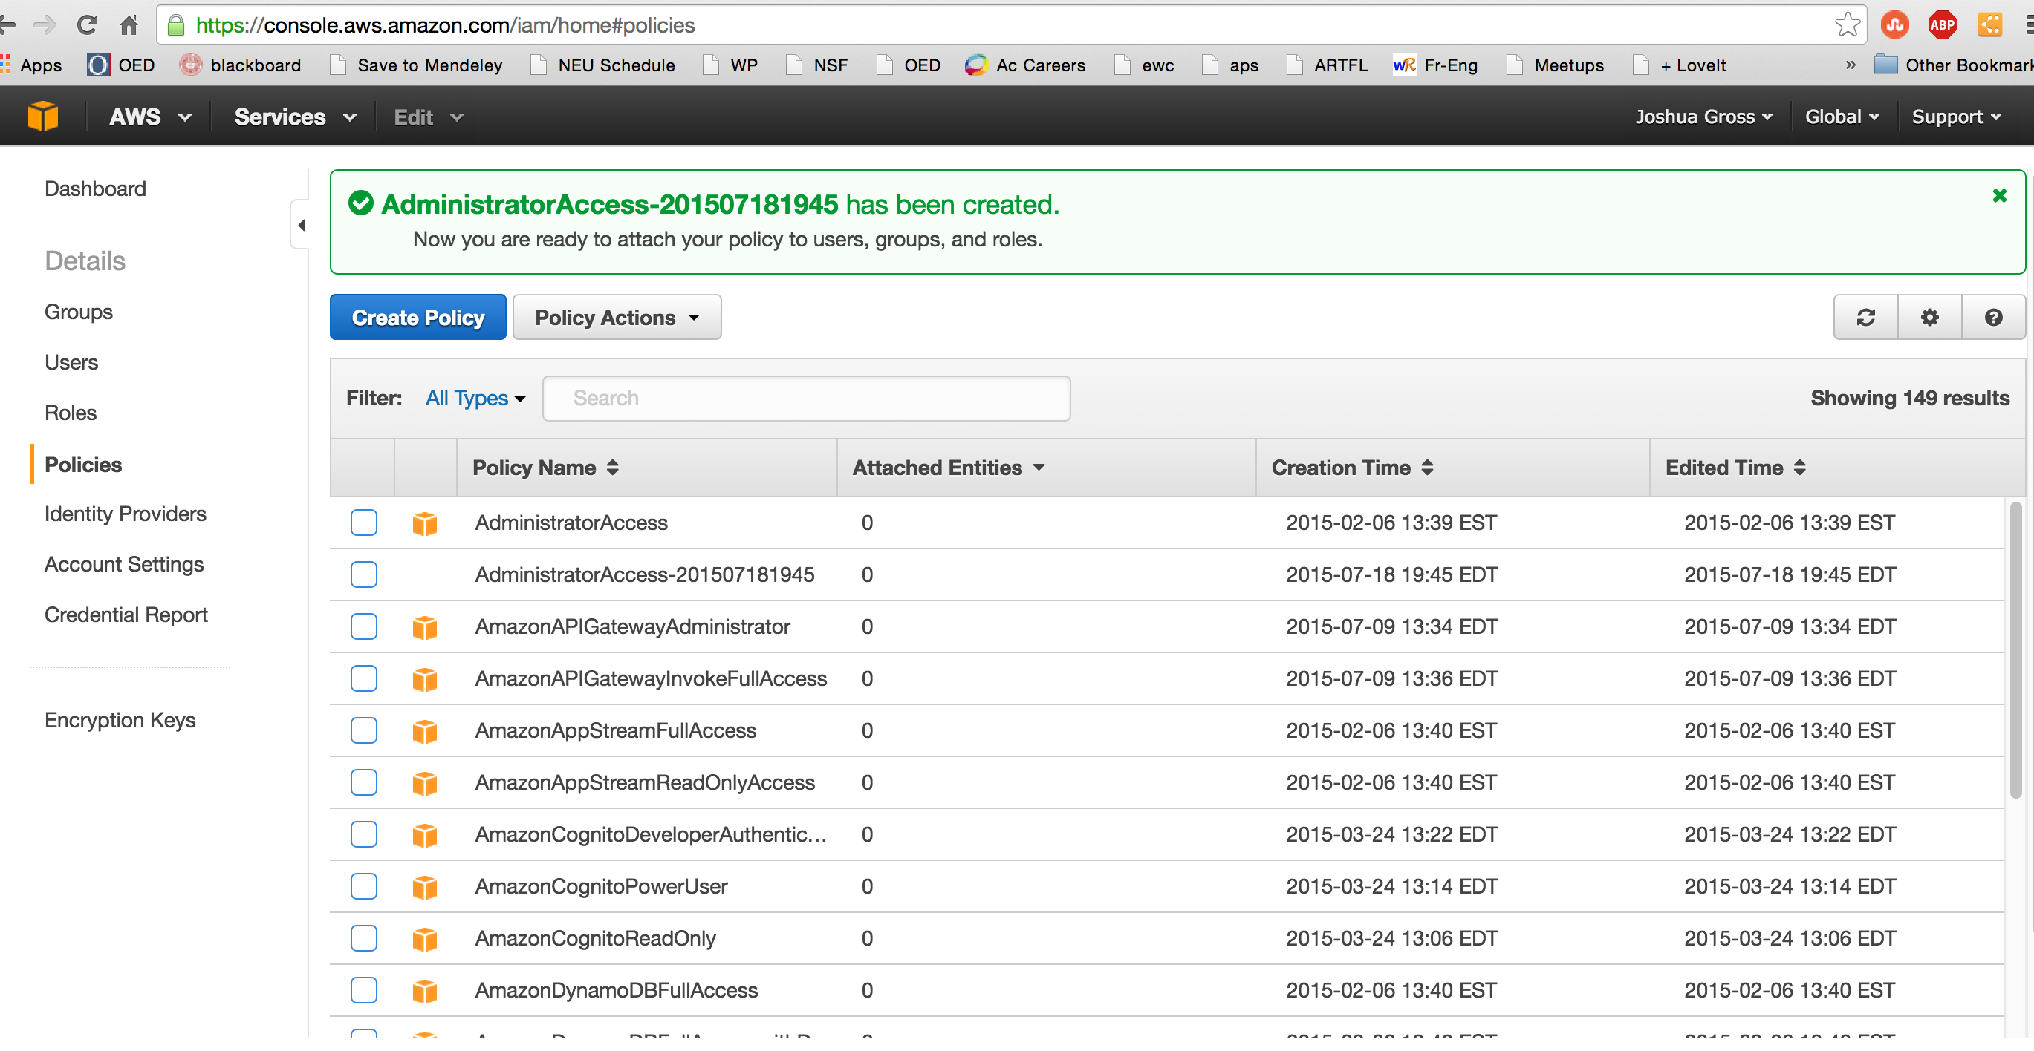

1. Check the box next to your new policy

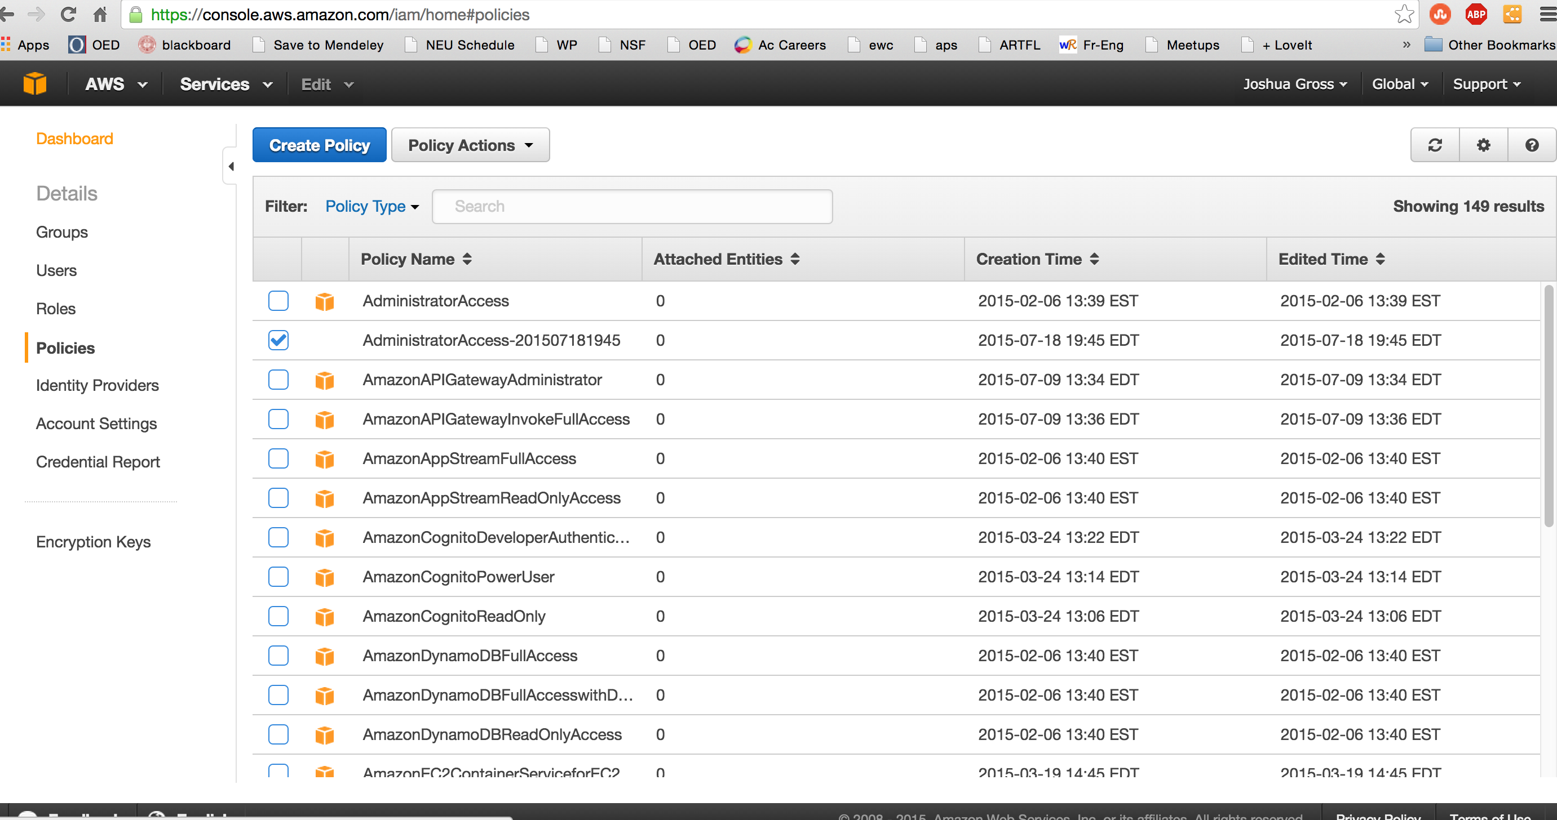

1. Select the “Policy Actions” button and select “Attach”

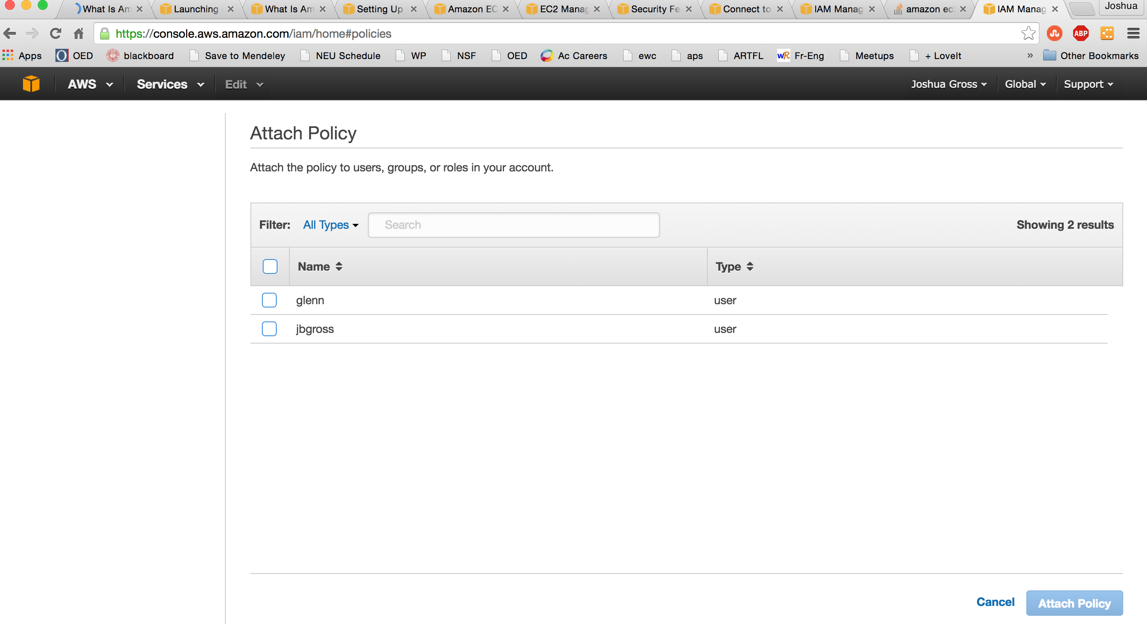

1. Select the user (or users) to attach the policy to

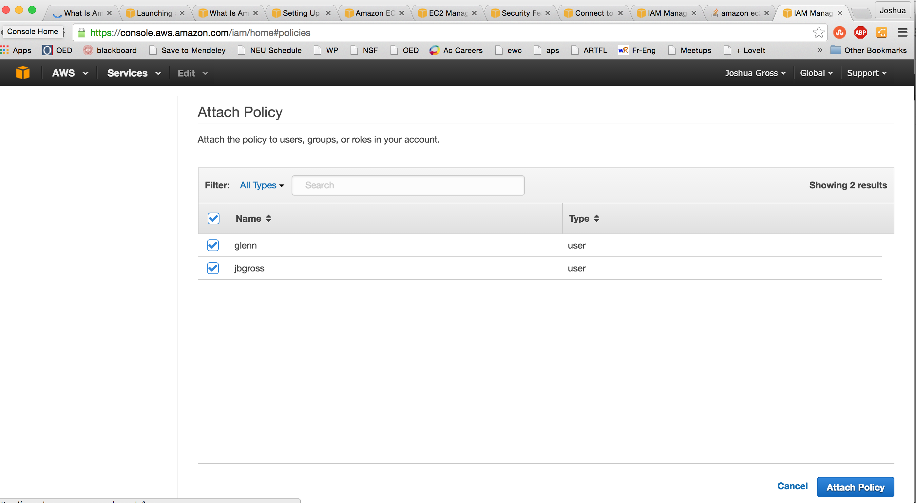

1. Select the “Attach Policy” button in the bottom right. NOTE: This is not the most secure security strategy. If we were going to use this for any real data, we would create more users, restrict administrator access to a few, and create limited access groups/policies for other users.

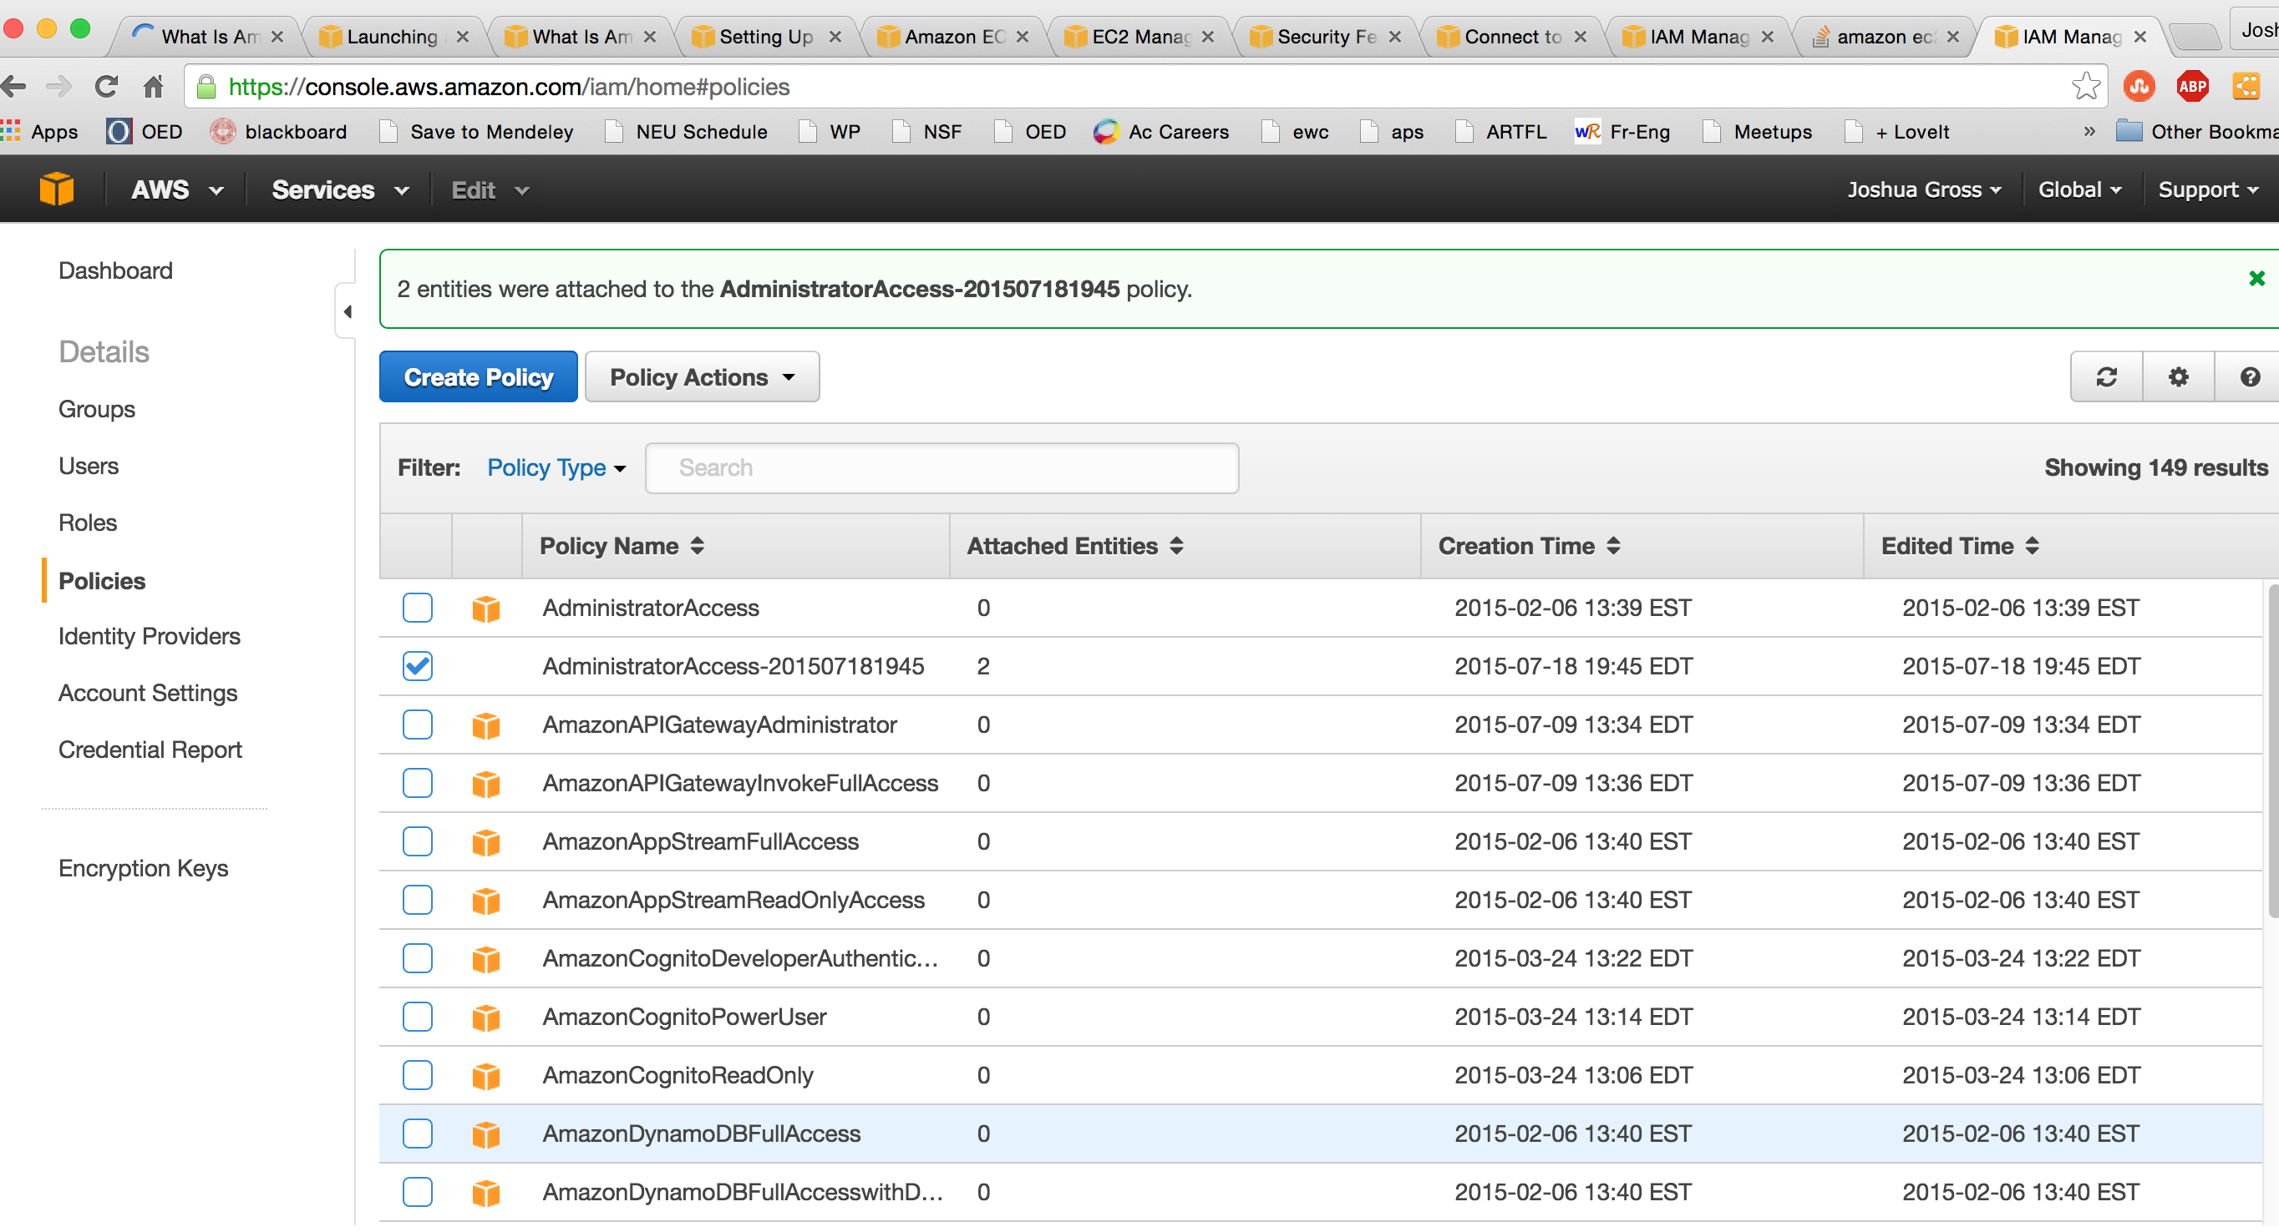

1. Install the CLI tools – these instructions are pretty good, but they’re different for Linux, Windows, and MacOS. During this process, you’ll need the two keys in the credentials file you downloaded earlier.

<http://docs.aws.amazon.com/AWSEC2/latest/CommandLineReference/set-up-ec2-cli-linux.html>

1. If you’ve installed everything properly and set up your environment properly, you should be able to execute the command “ec2-describe-regions”

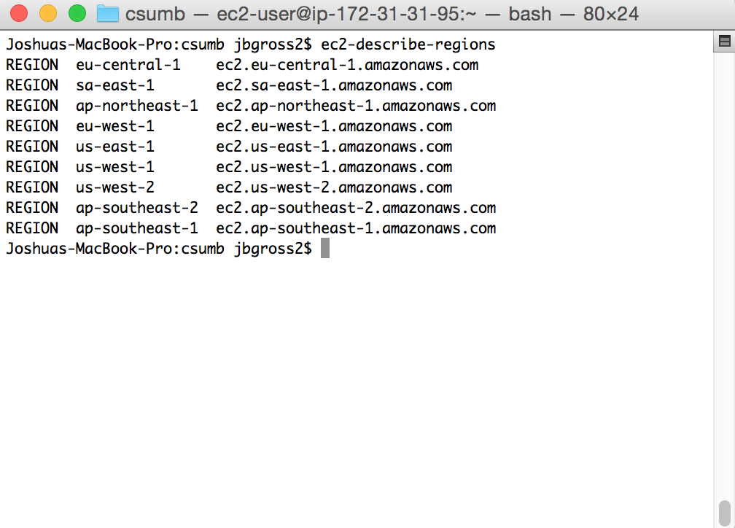

Step Two: Creating a Linux Server and Gaining Access

1. Go to the AWS main console: <https://us-west-2.console.aws.amazon.com/console/home?region=us-west-2>

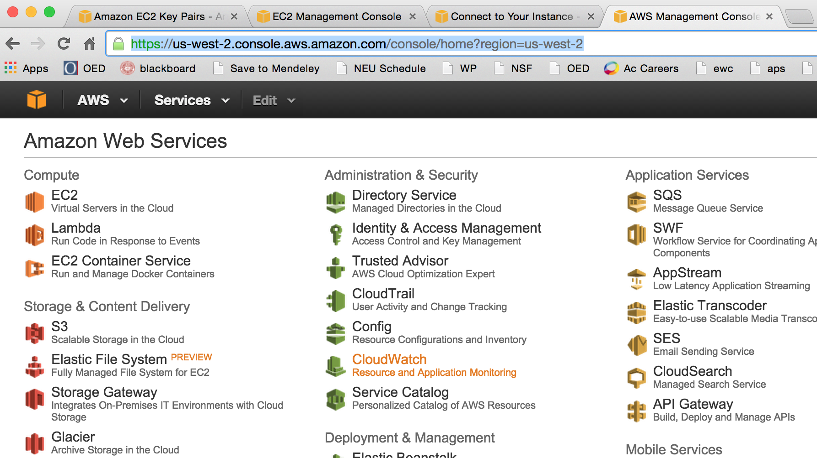

1. Select EC2 to create a new Elastic Cloud Computing server

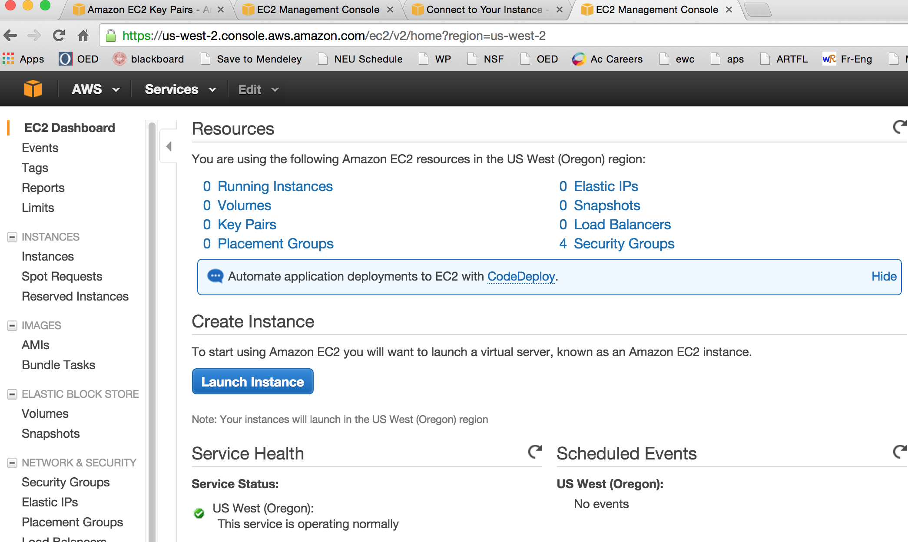

1. Select the “Launch Instance” button

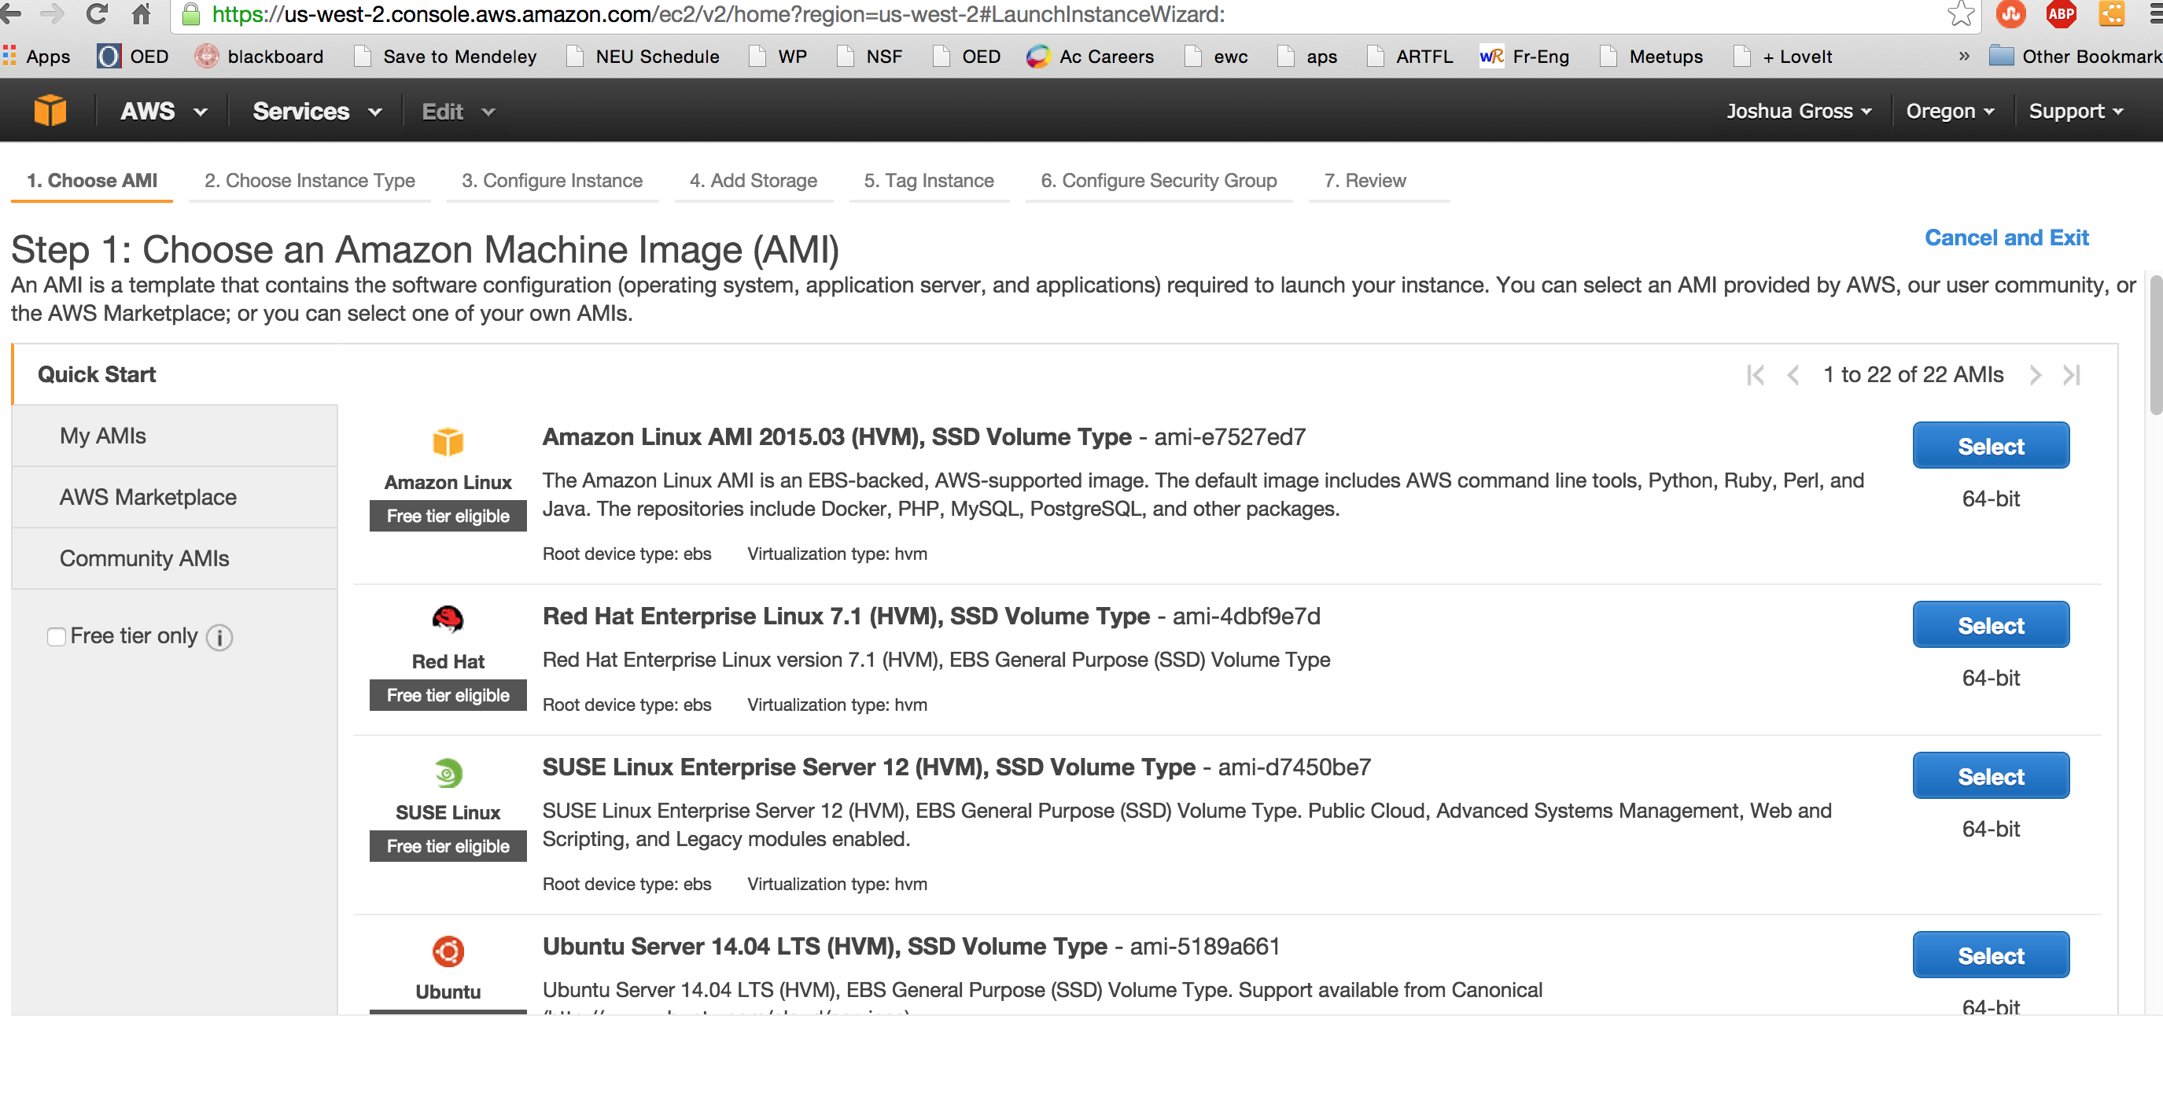

1. Select the Amazon Linux “Select” button.

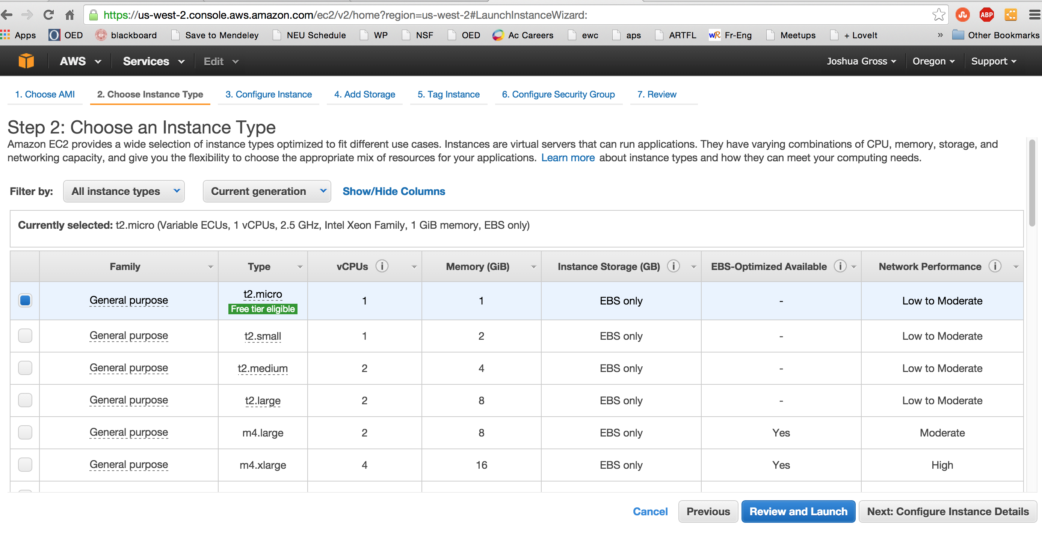

1. Select the “t2.micro” Instance Type and then select the “Review and Launch” button

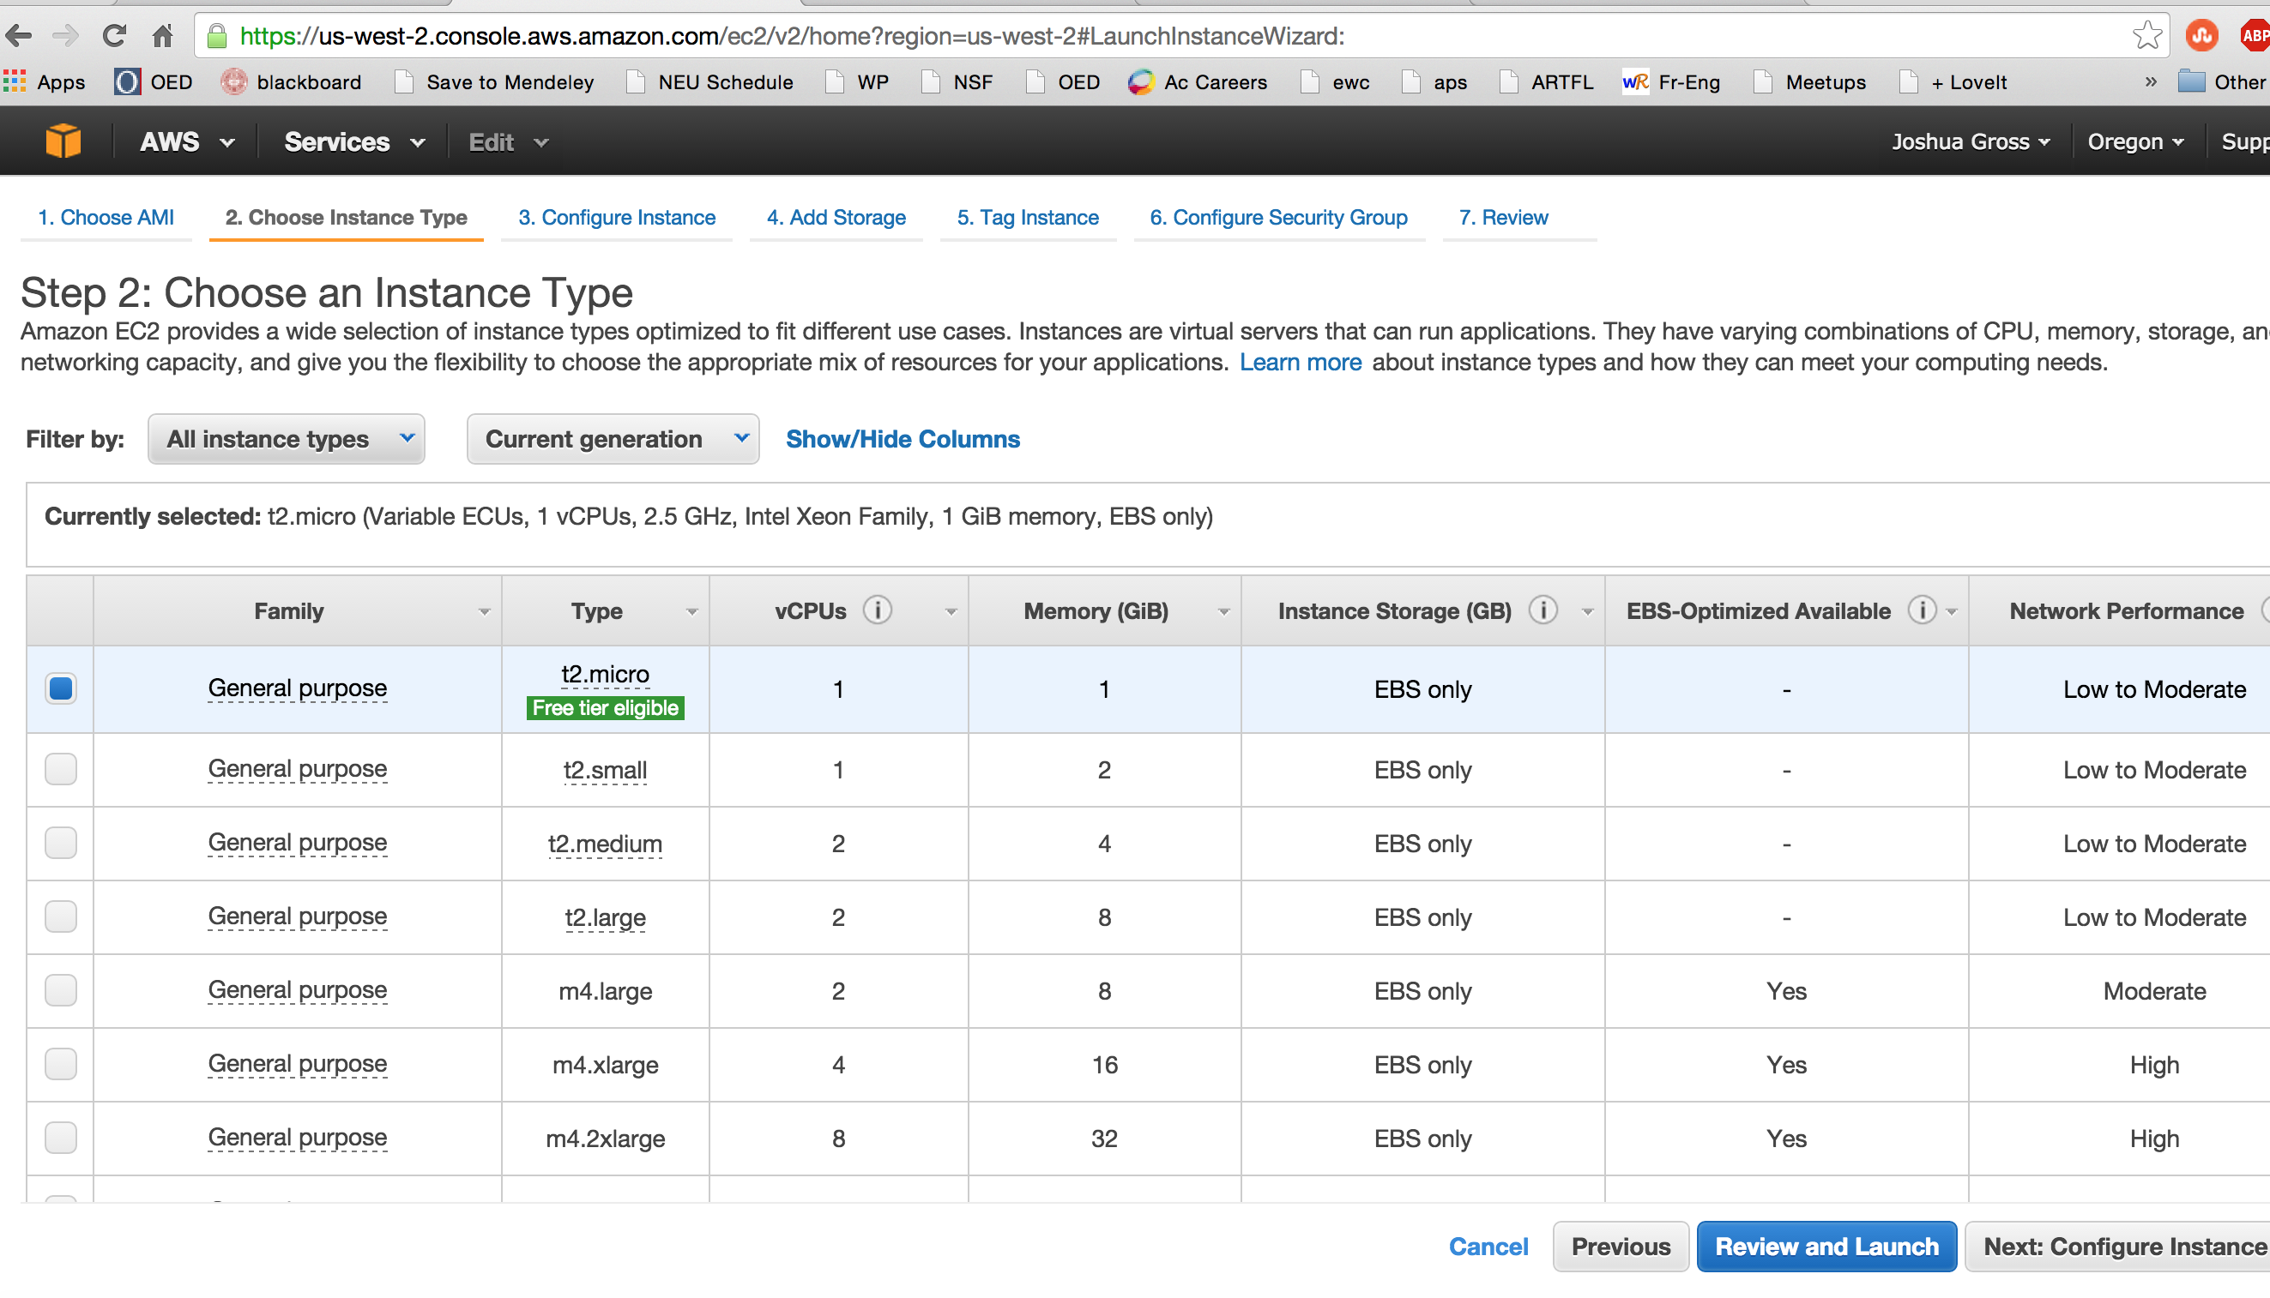

1. Review your instance to make sure you understand what you are starting up. You can have up to 30GB free EBS (Elastic Block Storage), the built-in storage, but we don’t need that much, so we’ll leave it at the default of 8GB. Note that EBS is not the same as S3, which is a different, shared storage system, of which you are limited to 5GB, but we’re not even going to set that up now. Once you are ready, select the “Launch” button. NOTE: As above, we could increase the security here; we’re going to allow ssh connections from anywhere.

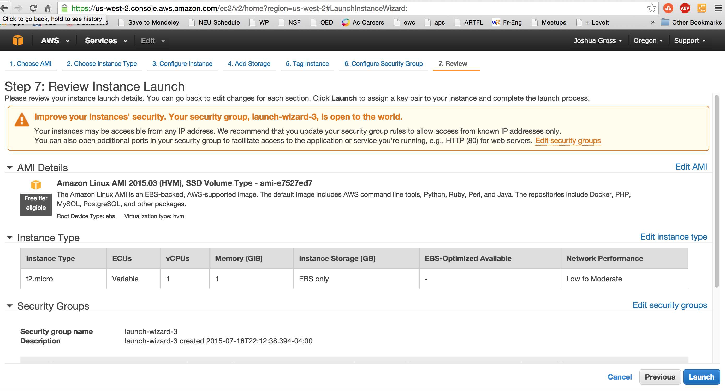

1. Select “Create a new key pair” on the dialog box and give it the Key pair name of your user (it doesn’t have to be your user, but we’ll use that name for convenience).

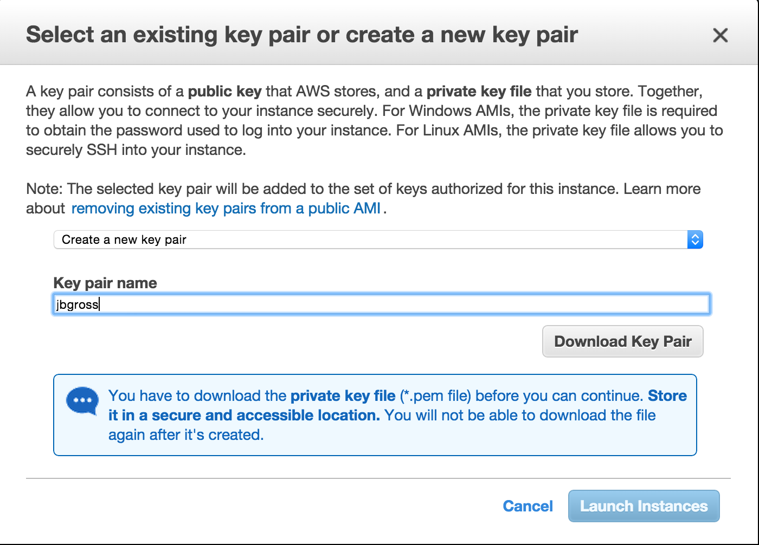

1. Select the “Download Key Pair” button. As the dialog notes, you won’t be able to download this again. You’ll need to remember where you downloaded the file; it’s name will be <username>.pem
2. Select the “Launch Instances” button.

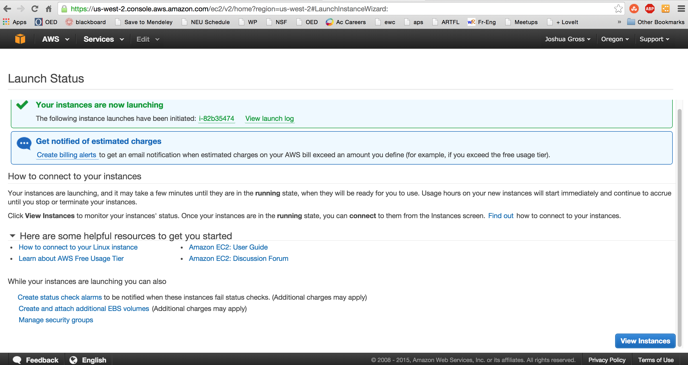

1. Select the “View Instances” button.

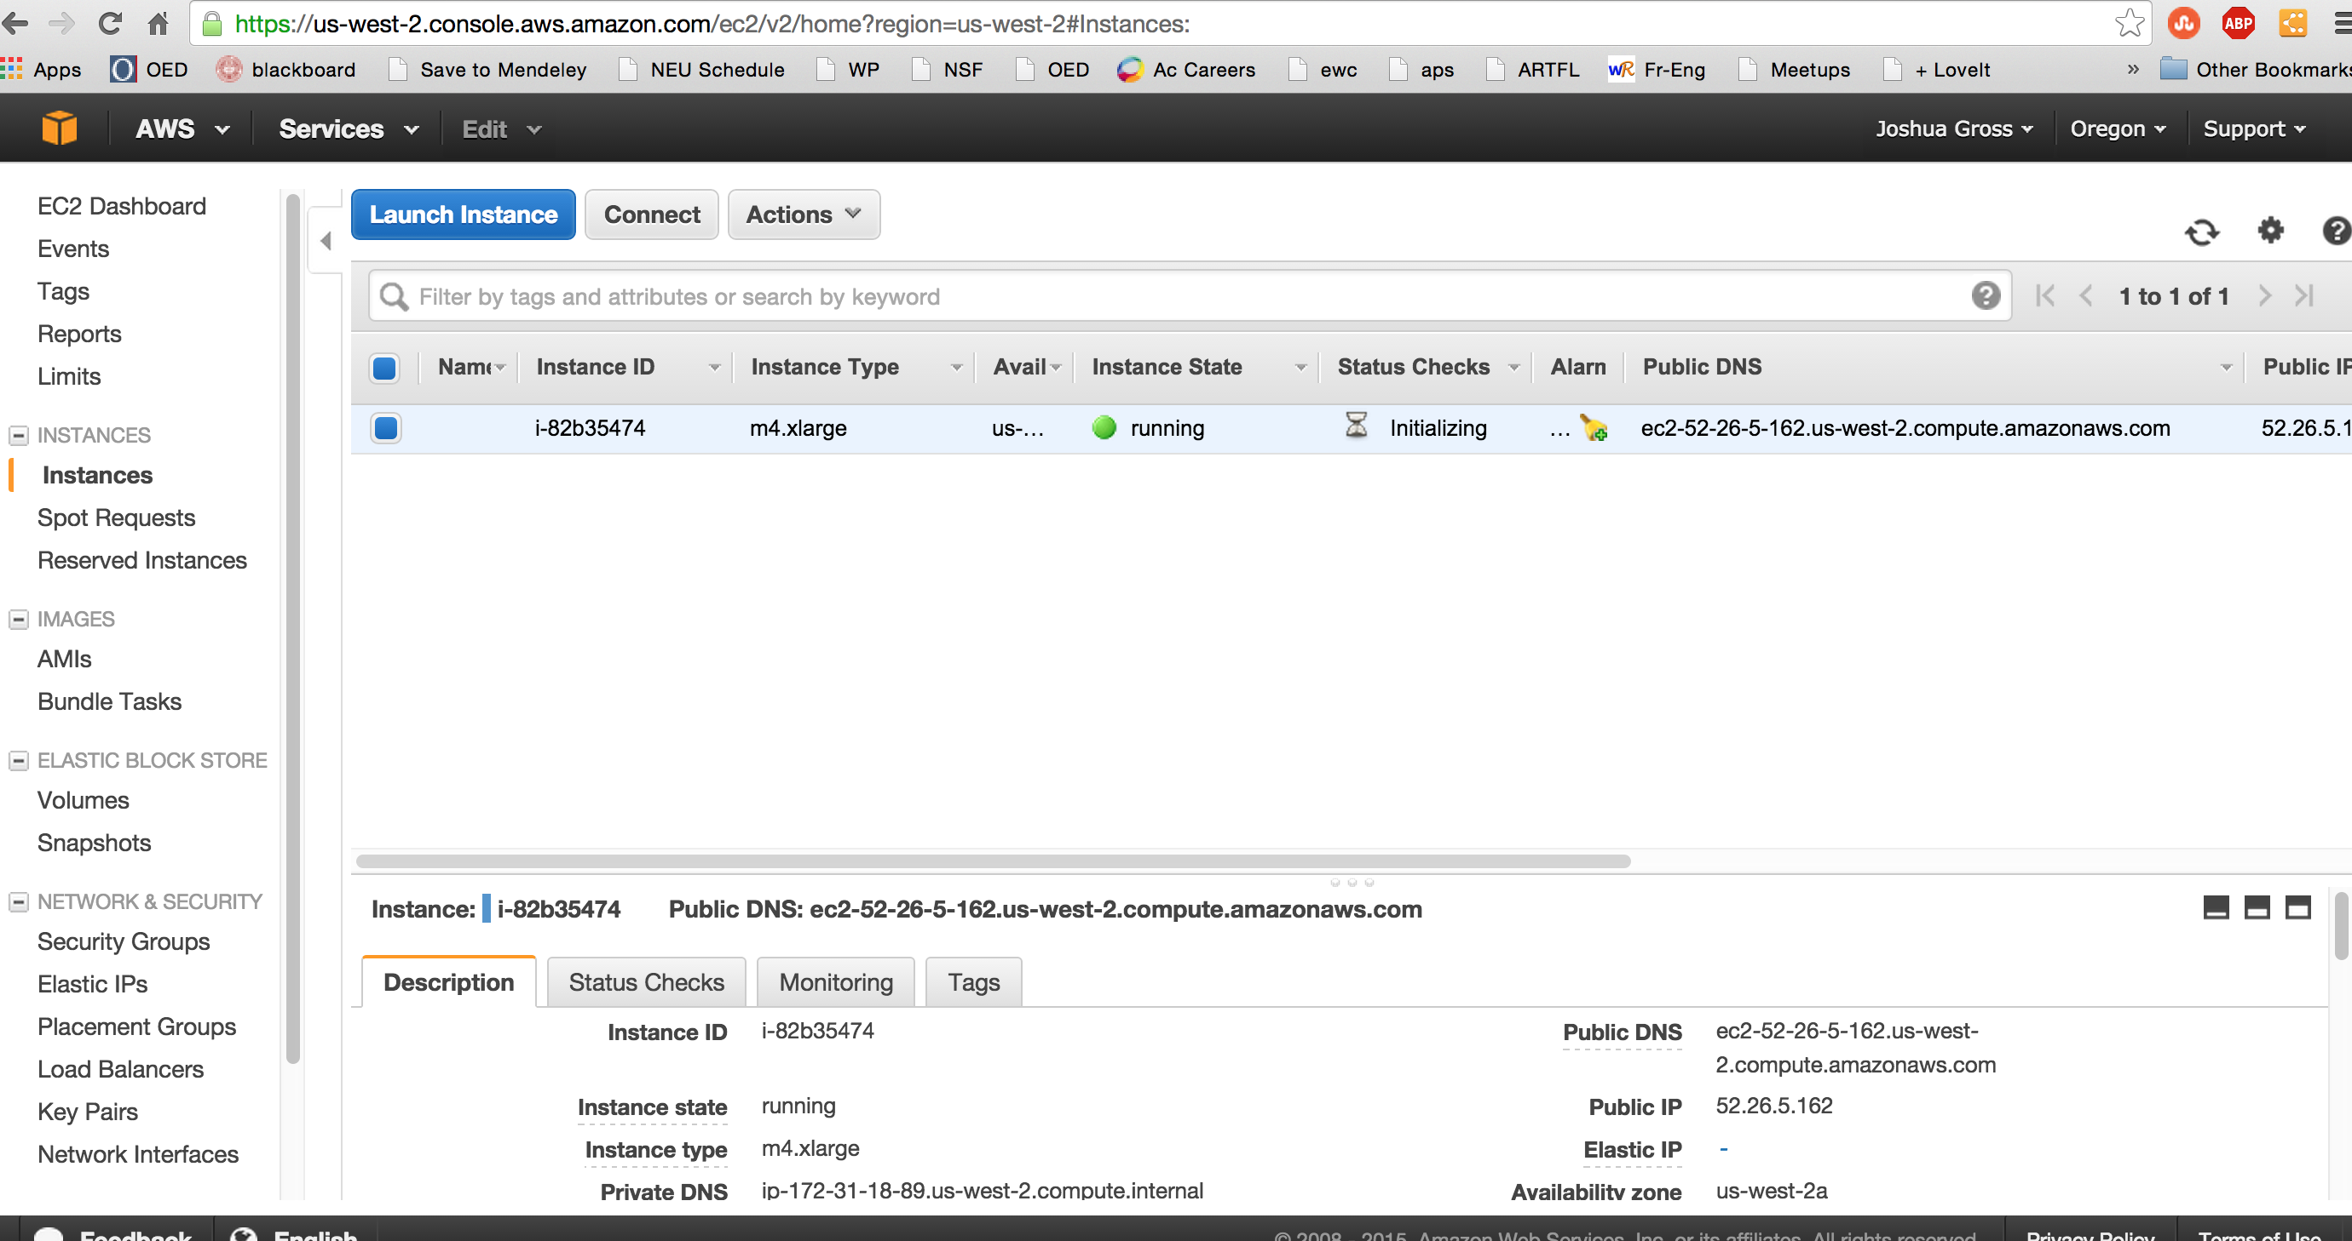

1. Wait for your server instance to complete booting. During the booting process, the Instance State will be “running” and the Status Checks will be “Initializing”. It will take a few minutes to complete booting. If you ever decide to cycle it (shut it down and reboot it), subsequent boots will be faster, but there’s no real need to cycle your instance or your database. Your free resources will allow you to have a server and a database running constantly. When the class is over, you may want to shut everything down. When the Status Checks reads “2/2 checks passed”, your server is up and running.

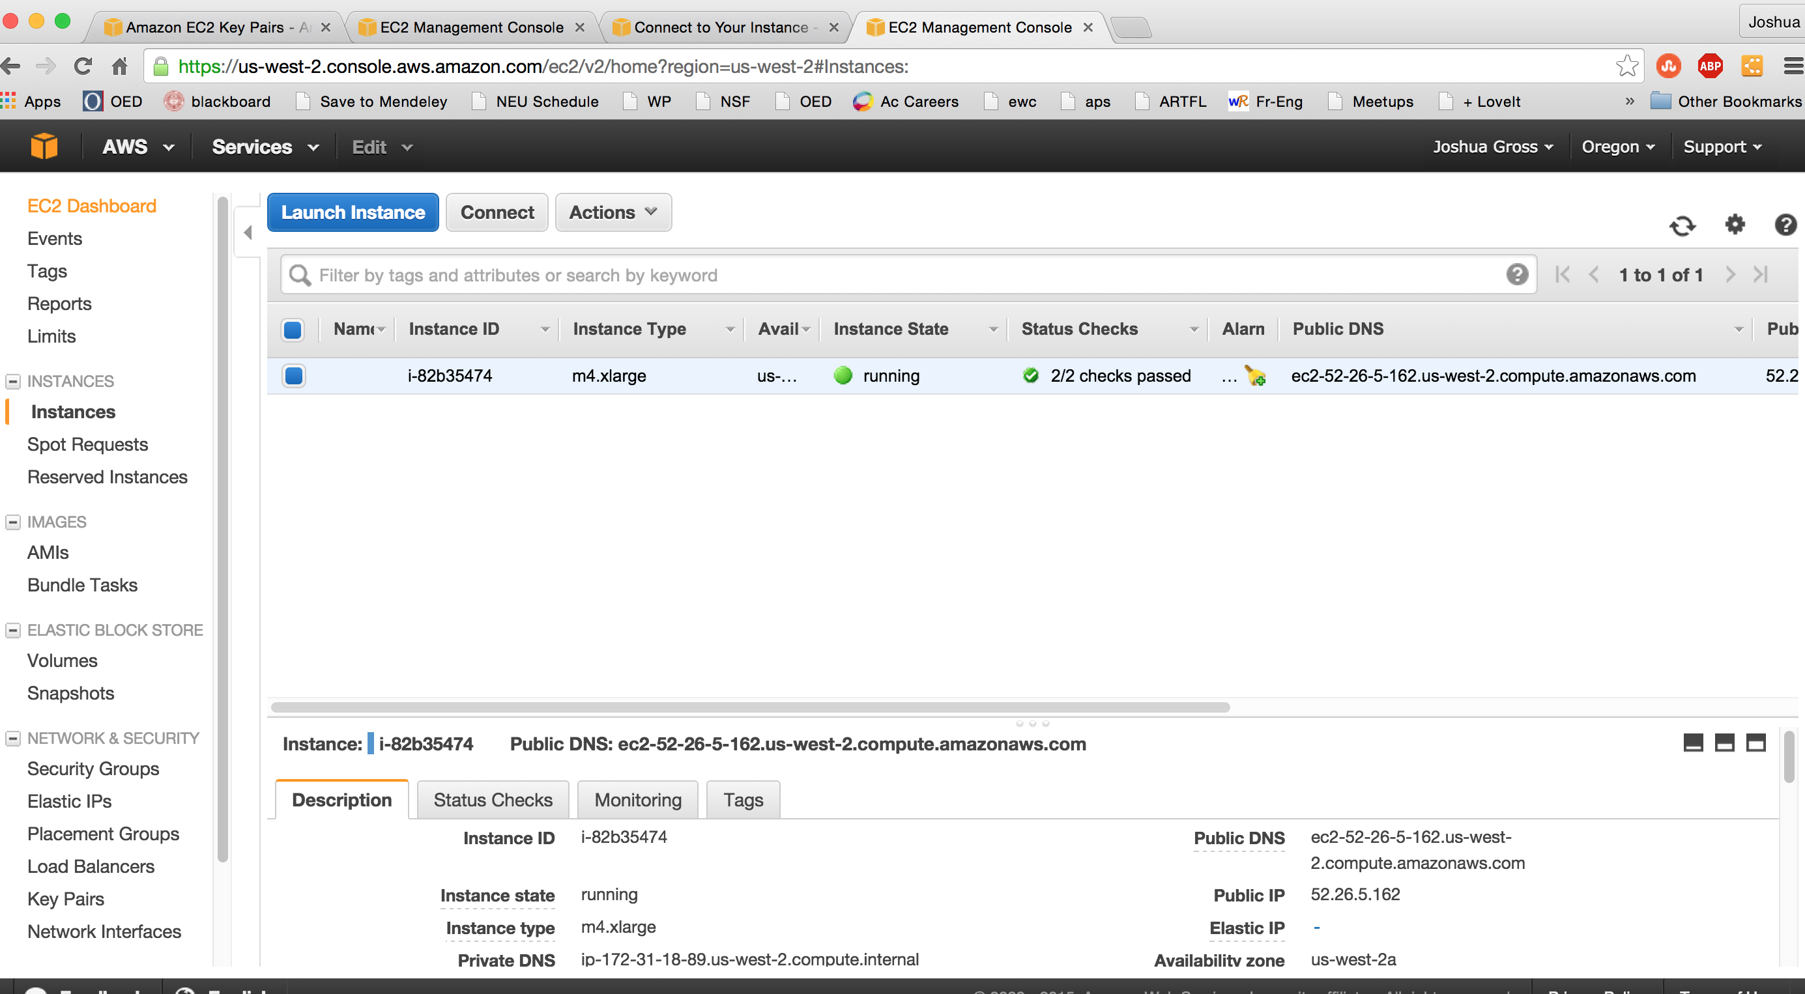

1. Now we will allow incoming traffic to your server instance. Select “Security Groups” on the bottom left with your server selected (the checkbox checked).

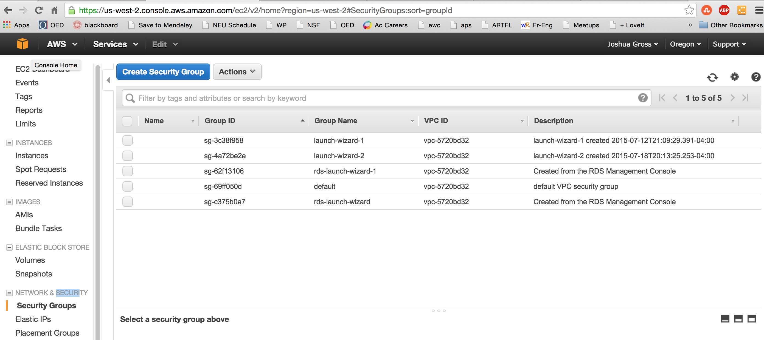

1. Select the checkbox for the “launch-wizard-1” group.

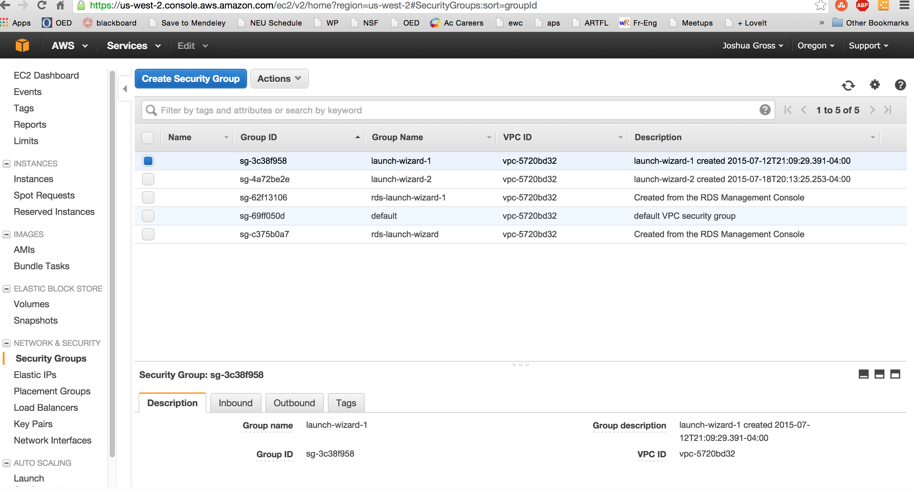

1. Select the “Inbound” tab on the bottom. You may need to scroll down a bit to see the rule(s).

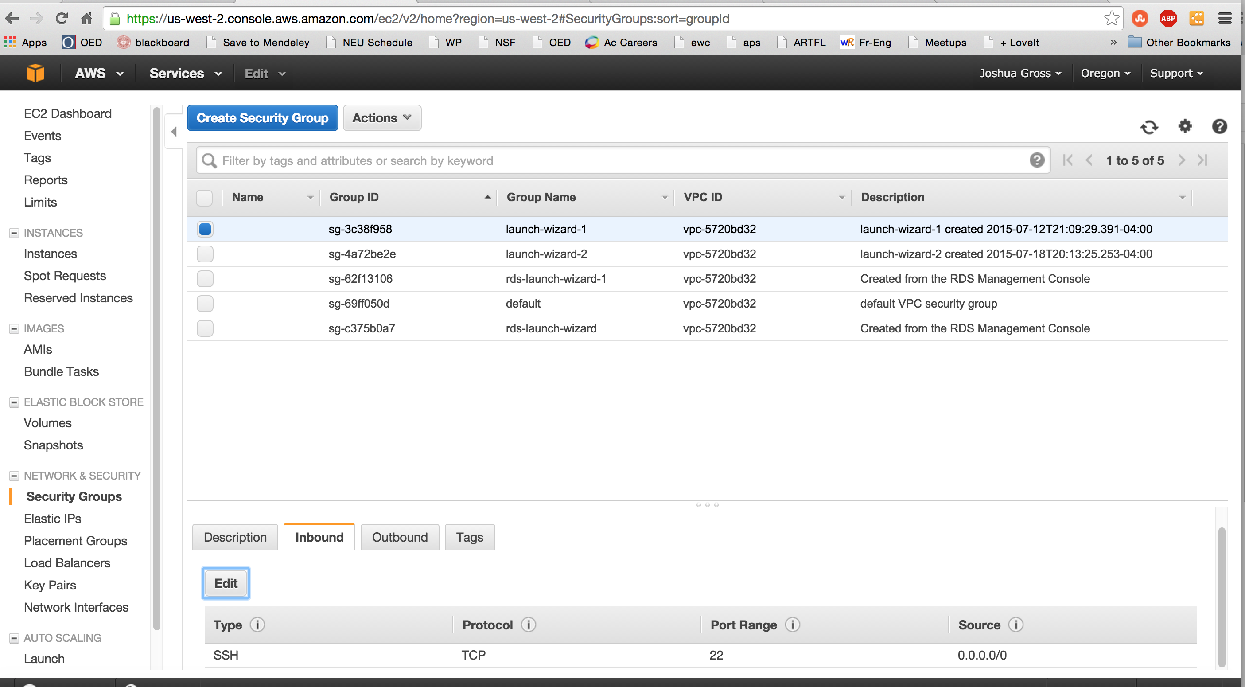

1. If you have the rule you see above, you’re done. This is the rule we were warned about earlier, and it allows ssh access for any user from anywhere in the world.



1. If you don’t have this rule, select the “Edit” button. The dialog box will open; set the Type to SSH, the Protocol to TCP, the Port Range to 22, the Source to Anywhere (in the dropdown) and 0.0.0.0/0 (in the text box). Then press the “Save” button. This says that any ssh connection is allowed, although it will be restricted to the user(s) you’ve created, and you’ll need the .pem file. EC2 Windows instances use passwords, as do MySQL databases, but Linux instances use keys.

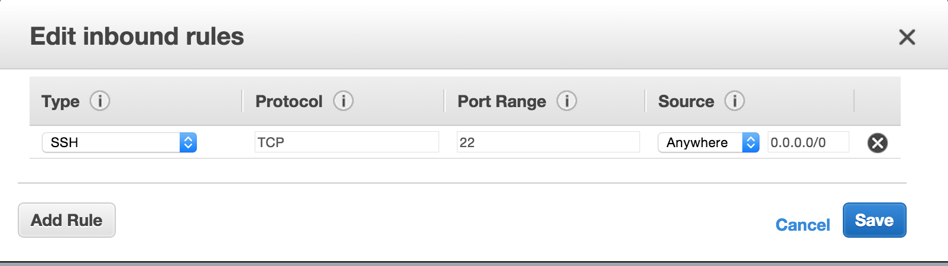

1. Select “EC2 Dashboard” on the top left.

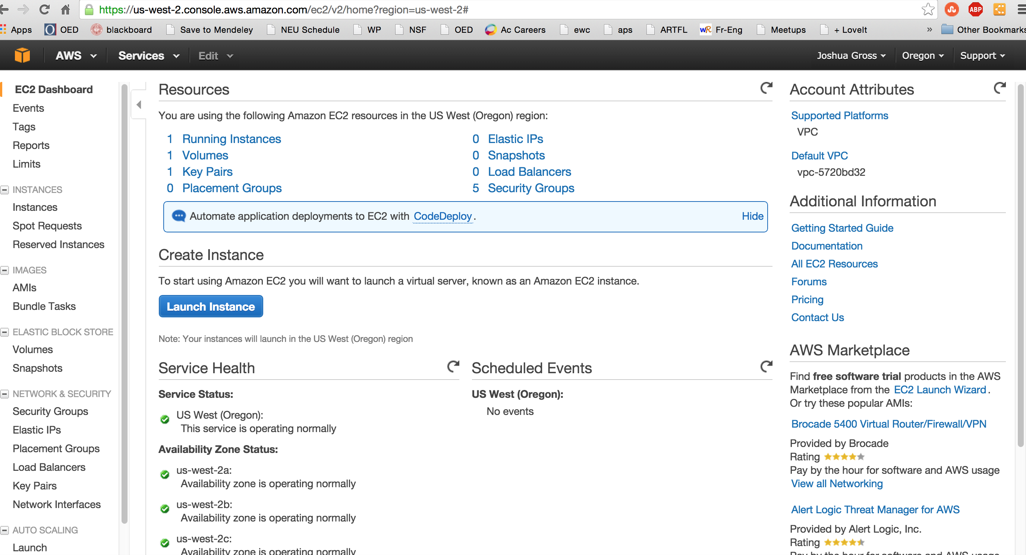

1. Select “1 Running Instances”.

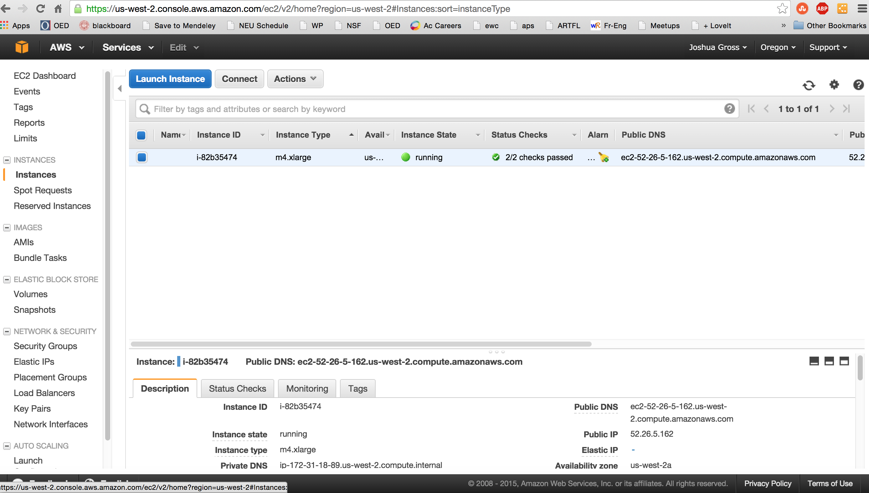

1. Notice that your server has a Public DNS; this is the address of the instance that you will use to log in via ssh. You’ll also need to locate the .pem file you downloaded earlier. These instances public/private key pairs to log in via ssh.
2. Follow the instructions for getting an ssh client (if you are on Windows; if you’re on MacOS or Linux, you already have one). The Linux instructions apply to MacOS. You will need to change the permissions of the .pem file with the command “chmod 400 <username>.pem” for Linx or MacOS. As you can see below, the file is now readable only by the owner.

<http://docs.aws.amazon.com/AWSEC2/latest/UserGuide/AccessingInstances.html>

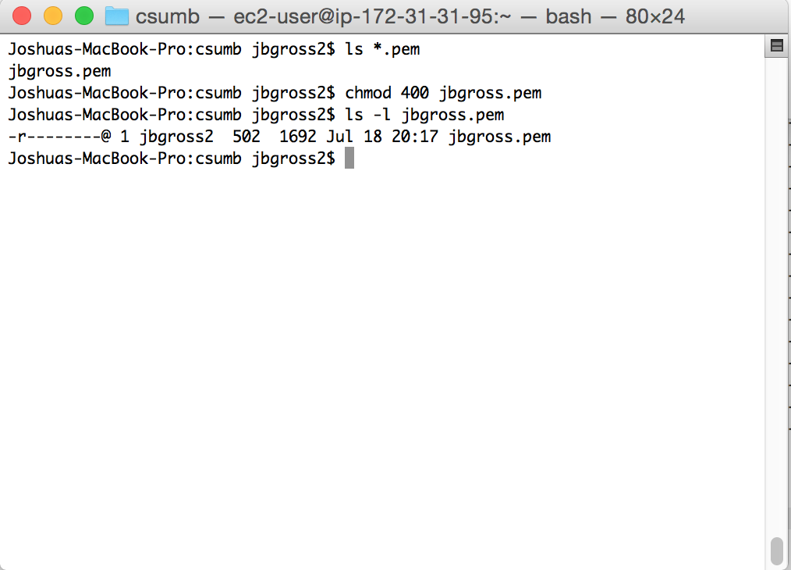

1. Connect to your server instance with ssh using the command below, substituting your username and DNS name

ssh –i <username>.pem [ec2-user@<dnsname>.compute.amazon.com](mailto:ec2-user@%3cdnsname%3e.compute.amazon.com)

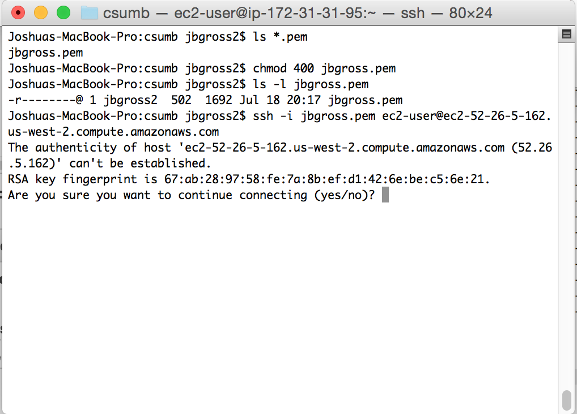

1. Type “yes” (not “y”) to accept the key. You only need to do this the first time you log into a server.

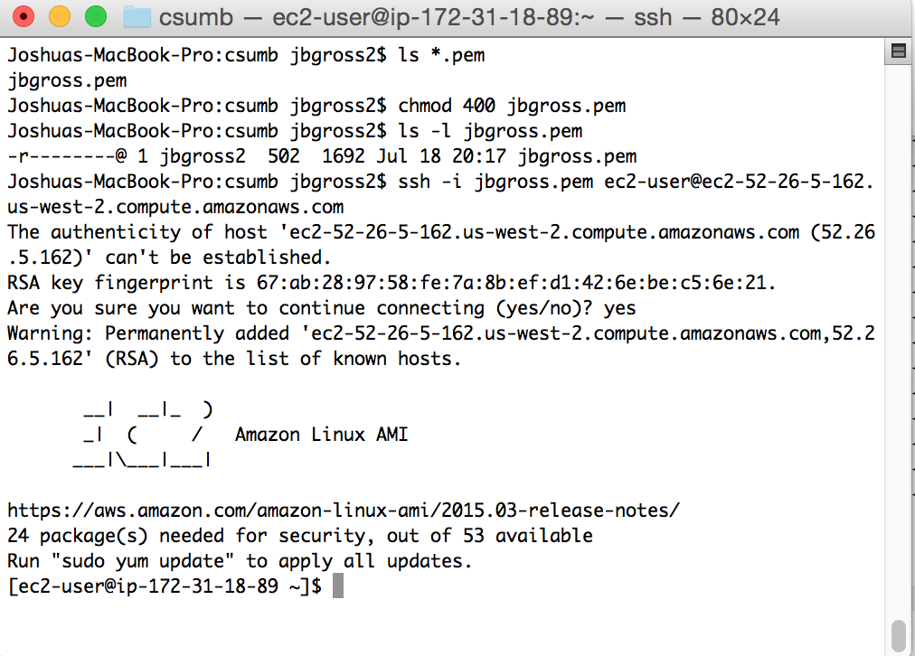

1. The server will tell you that you need to update some of the installed software; this is normal. Just follow the directions and type “sudo yum update”. The command means this: “sudo” runs commands as root, the system administrator, “yum” is the package updater, kind of like Windows Update or Software Update on the Mac, and “update” just tells yum to update all out-of-date packages. Once you start the update, you’ll have to accept the update size (this time you can just type “y”).

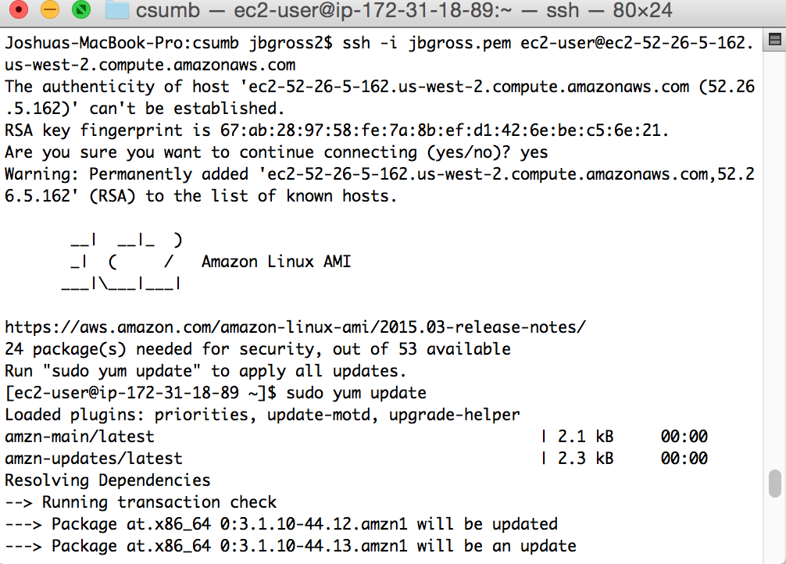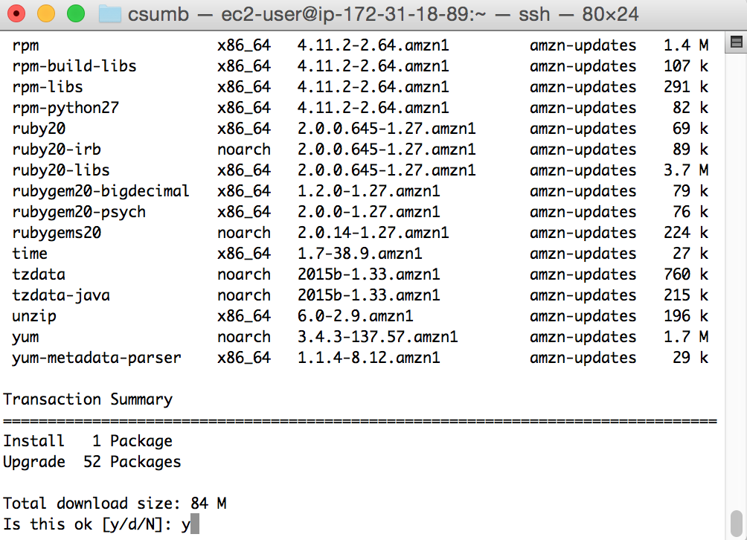

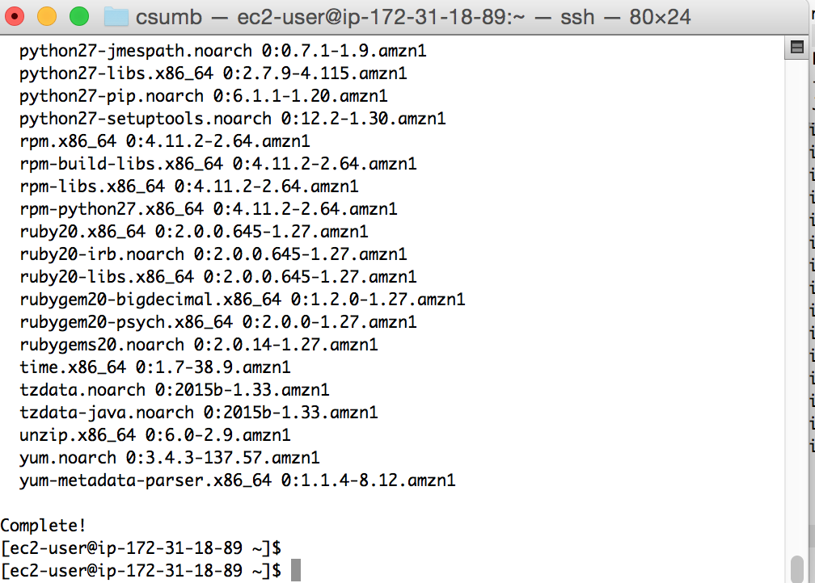

1. Now your server is up, running, and ready. In the future, you can run the same ssh command to log in. Again, there is no reason to shut down your server instance or your database instance, although if you do, you can restart them using the EC2 Console.

Step Three: Installing MySQL on Your Server Instance

Now we need to install the MySQL software on the server instance you just created. To do this, you’ll start at the command prompt.

1. At the prompt, enter the text “yum install mysql” and press enter.

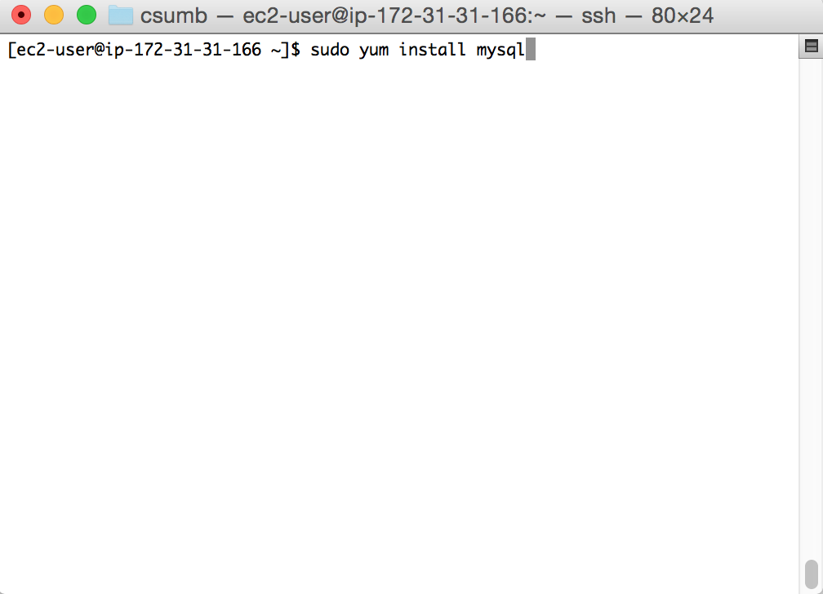

1. You will be asked to confirm the download and install; enter “y” to confirm.

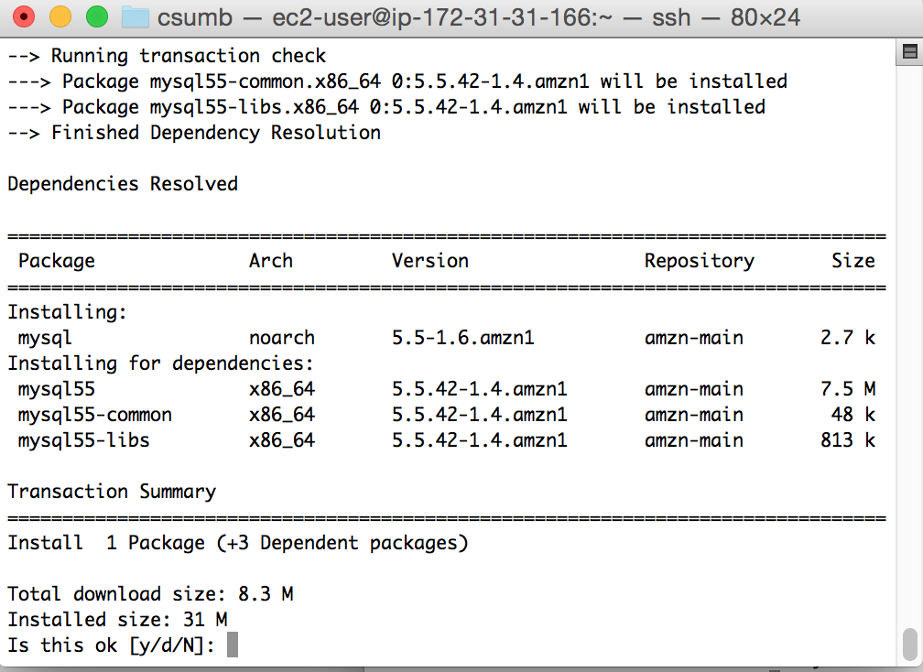

We aren’t actually going to run MySQL here; it’s much easier to use Amazon’s prebuilt database instance. What we need MySQL installed here for is the client (mysql) and the administration client (mysqladmin). We will be using this software in Step Six.

Step Four: Creating a Database Instance and Gaining Access

1. On your EC2 console, select the “Services” tab on the top left. Your history will NOT be populated like mine until you do a bit more.

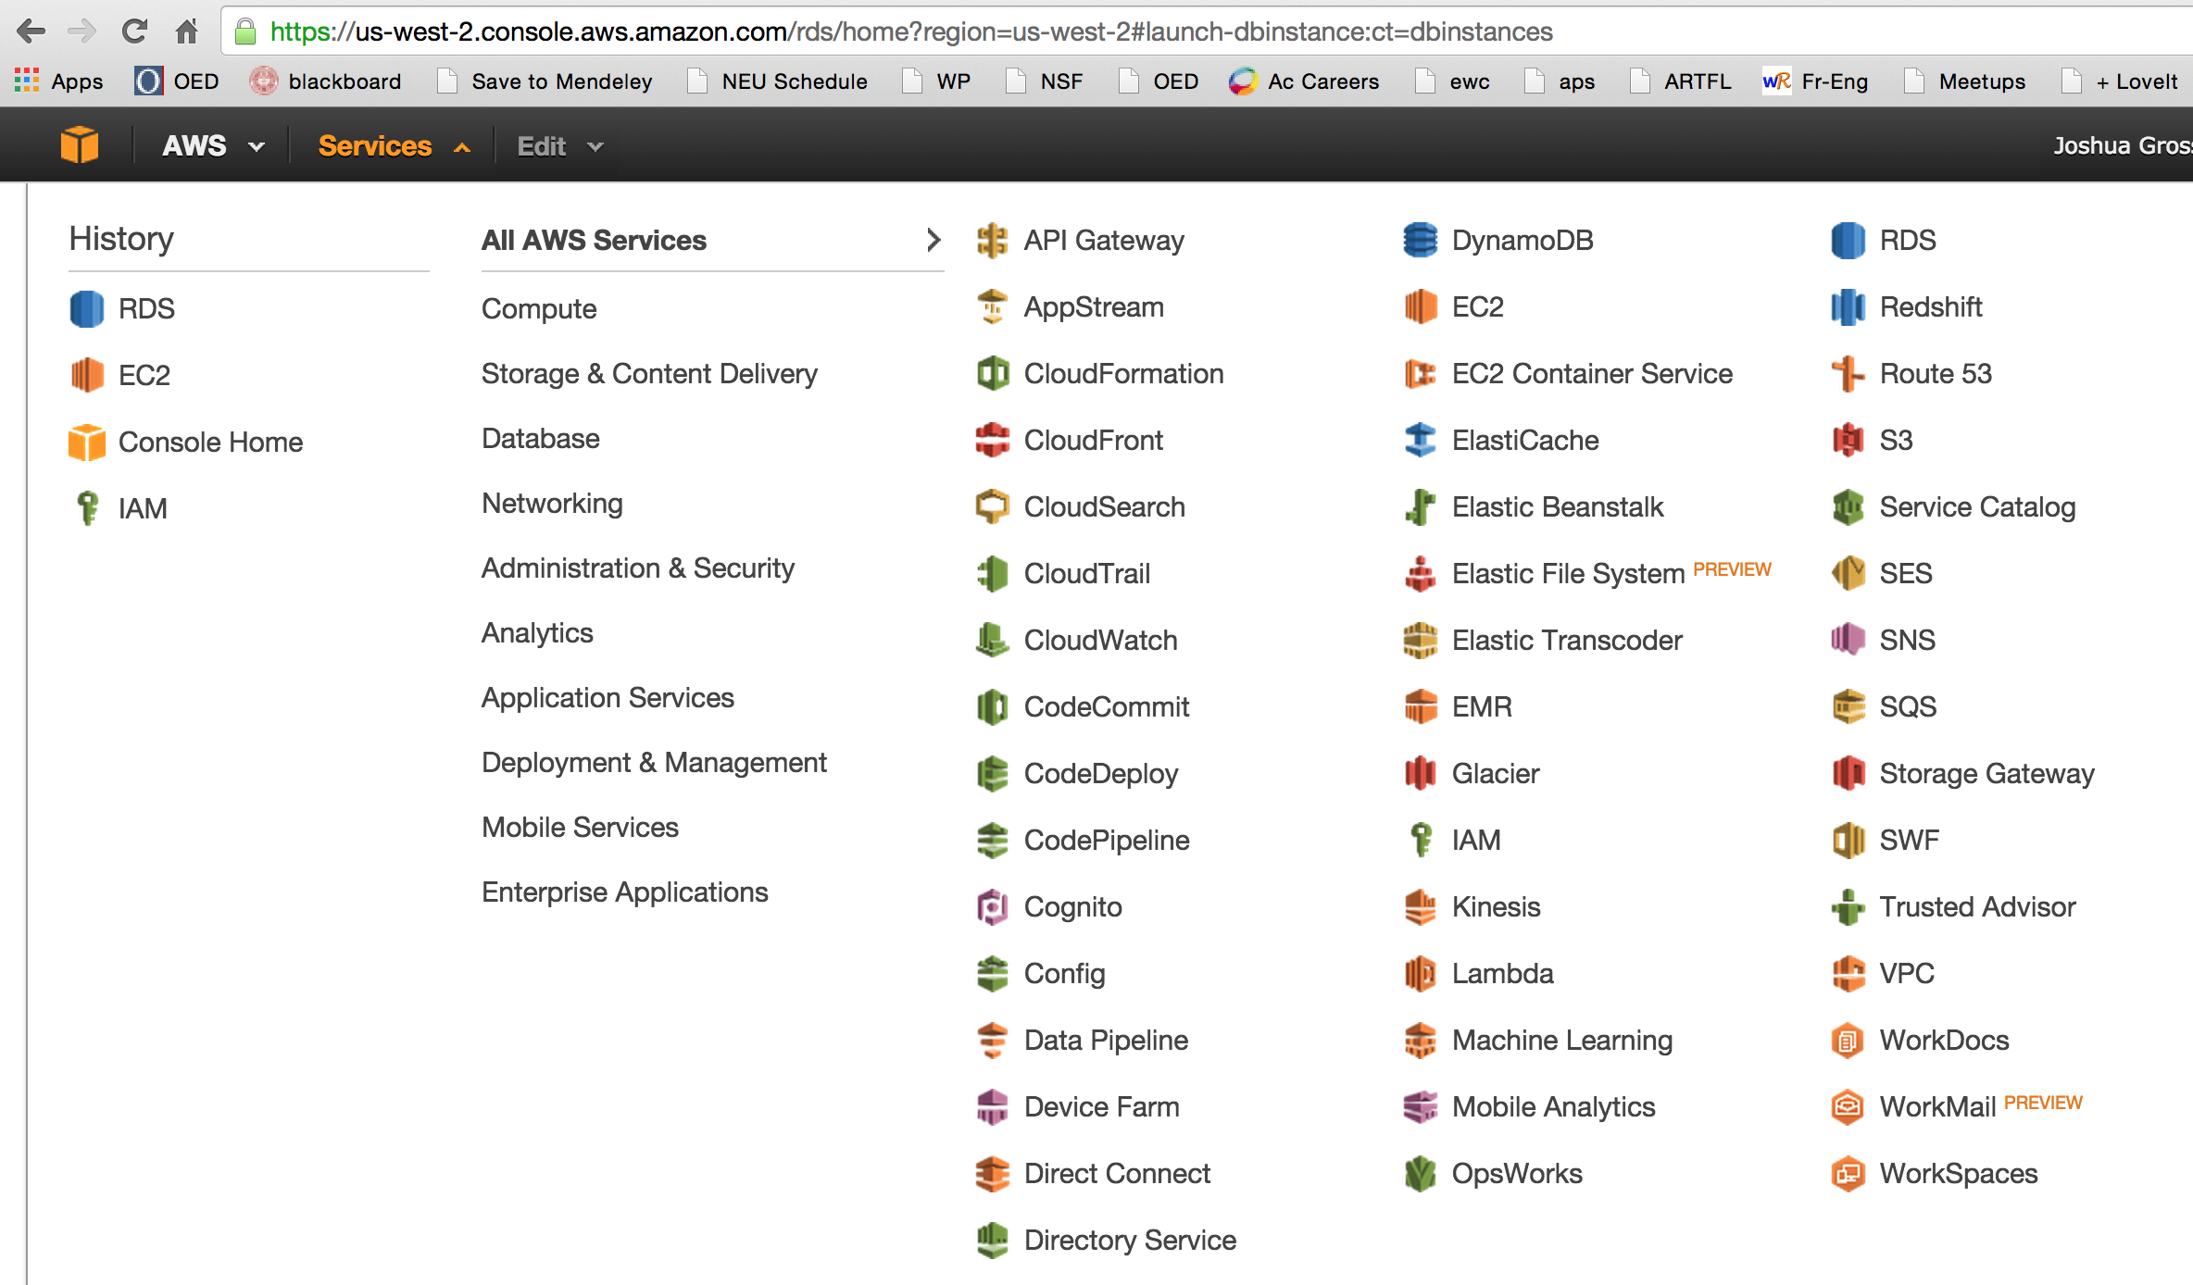

1. Select RDS (Relational Database Service) from All AWS Services; note that the list is in alphabetical order. This will bring you to the RDS Dashboard, where you will select “Instances” on the left list.

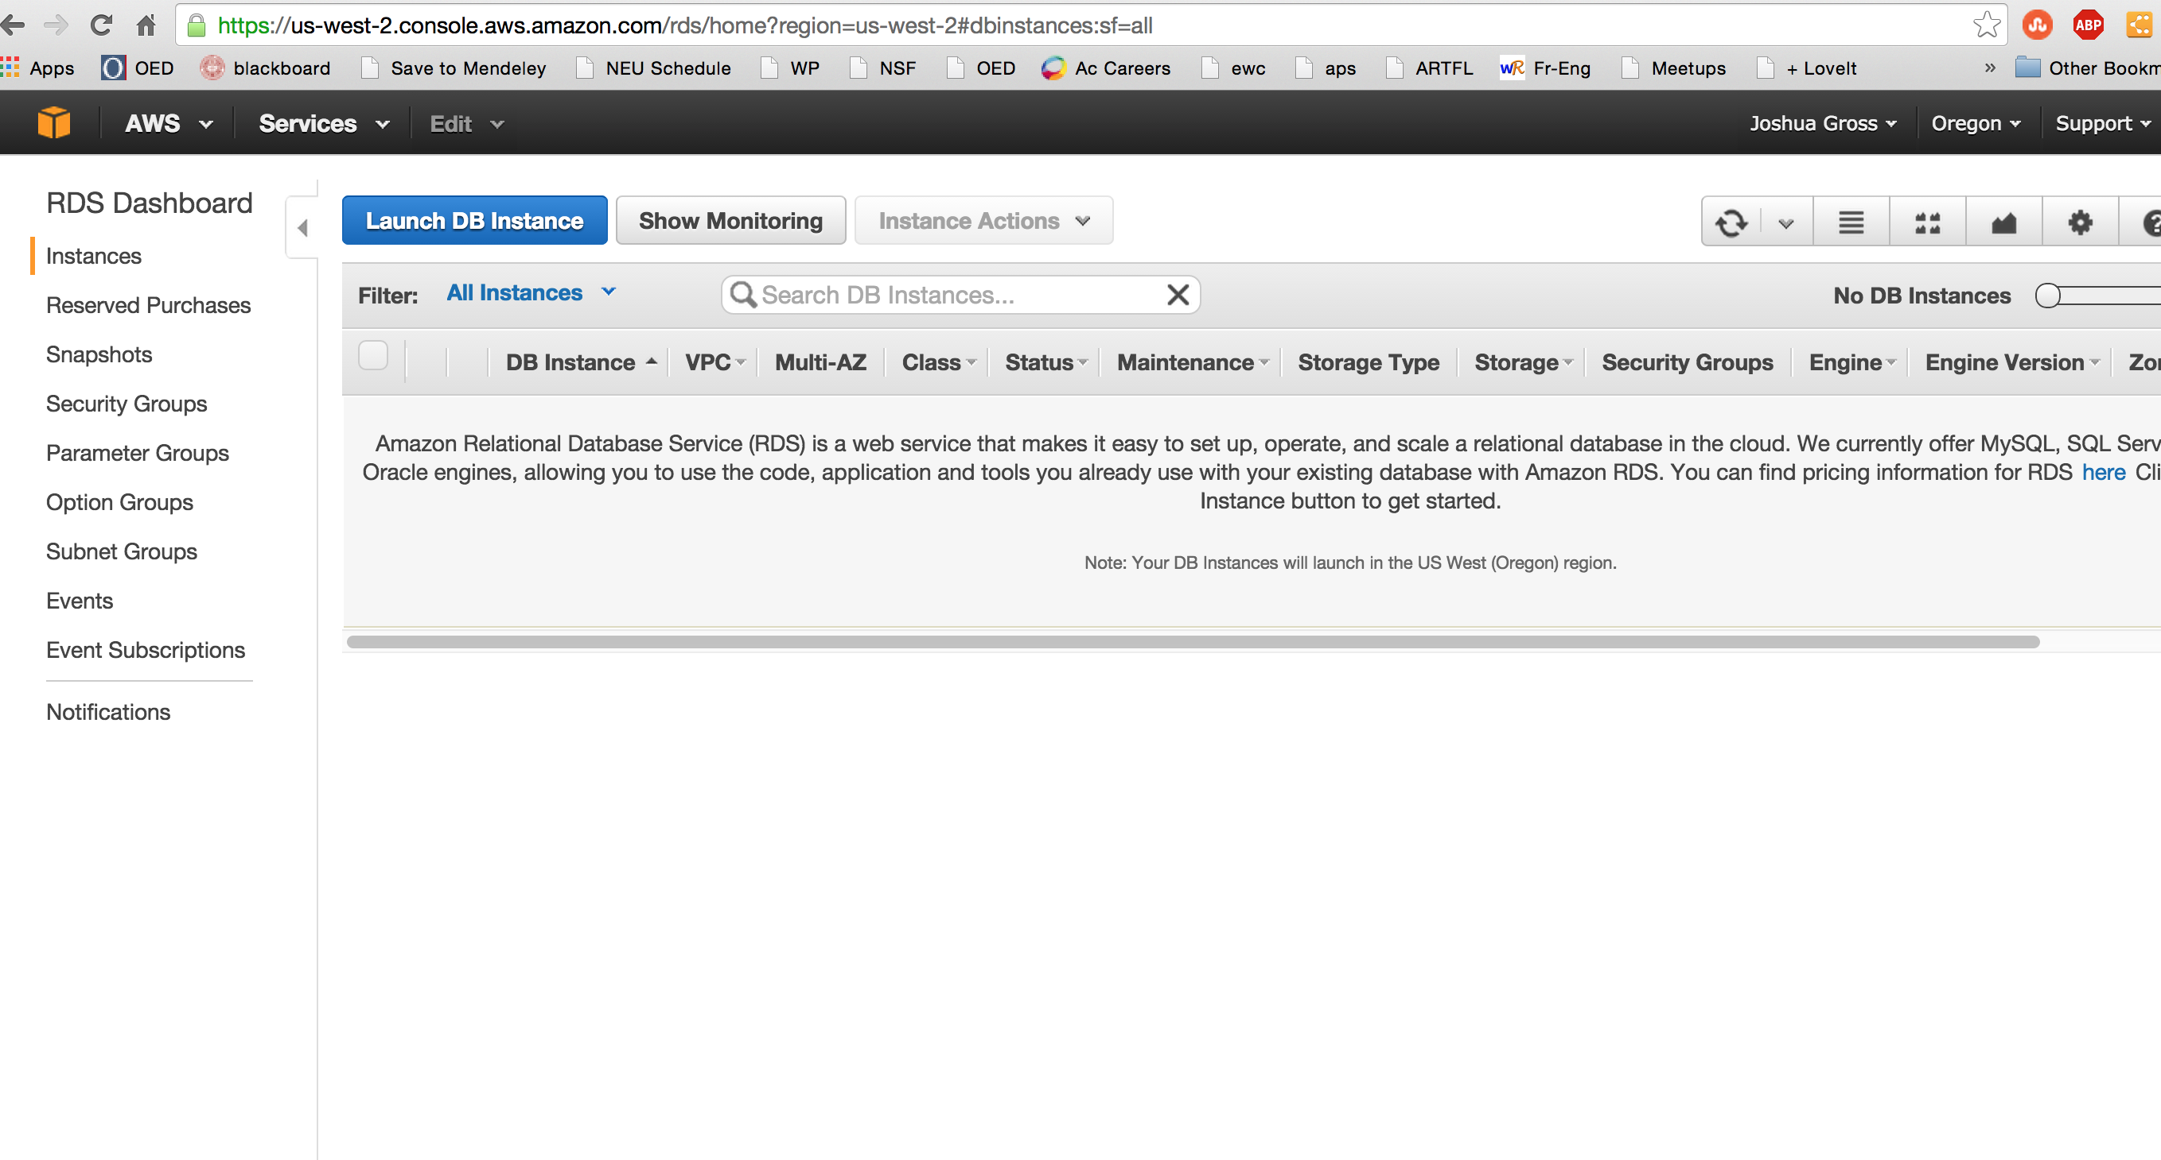

1. You will have no instances running. Select the “Launch DB Instance” button.

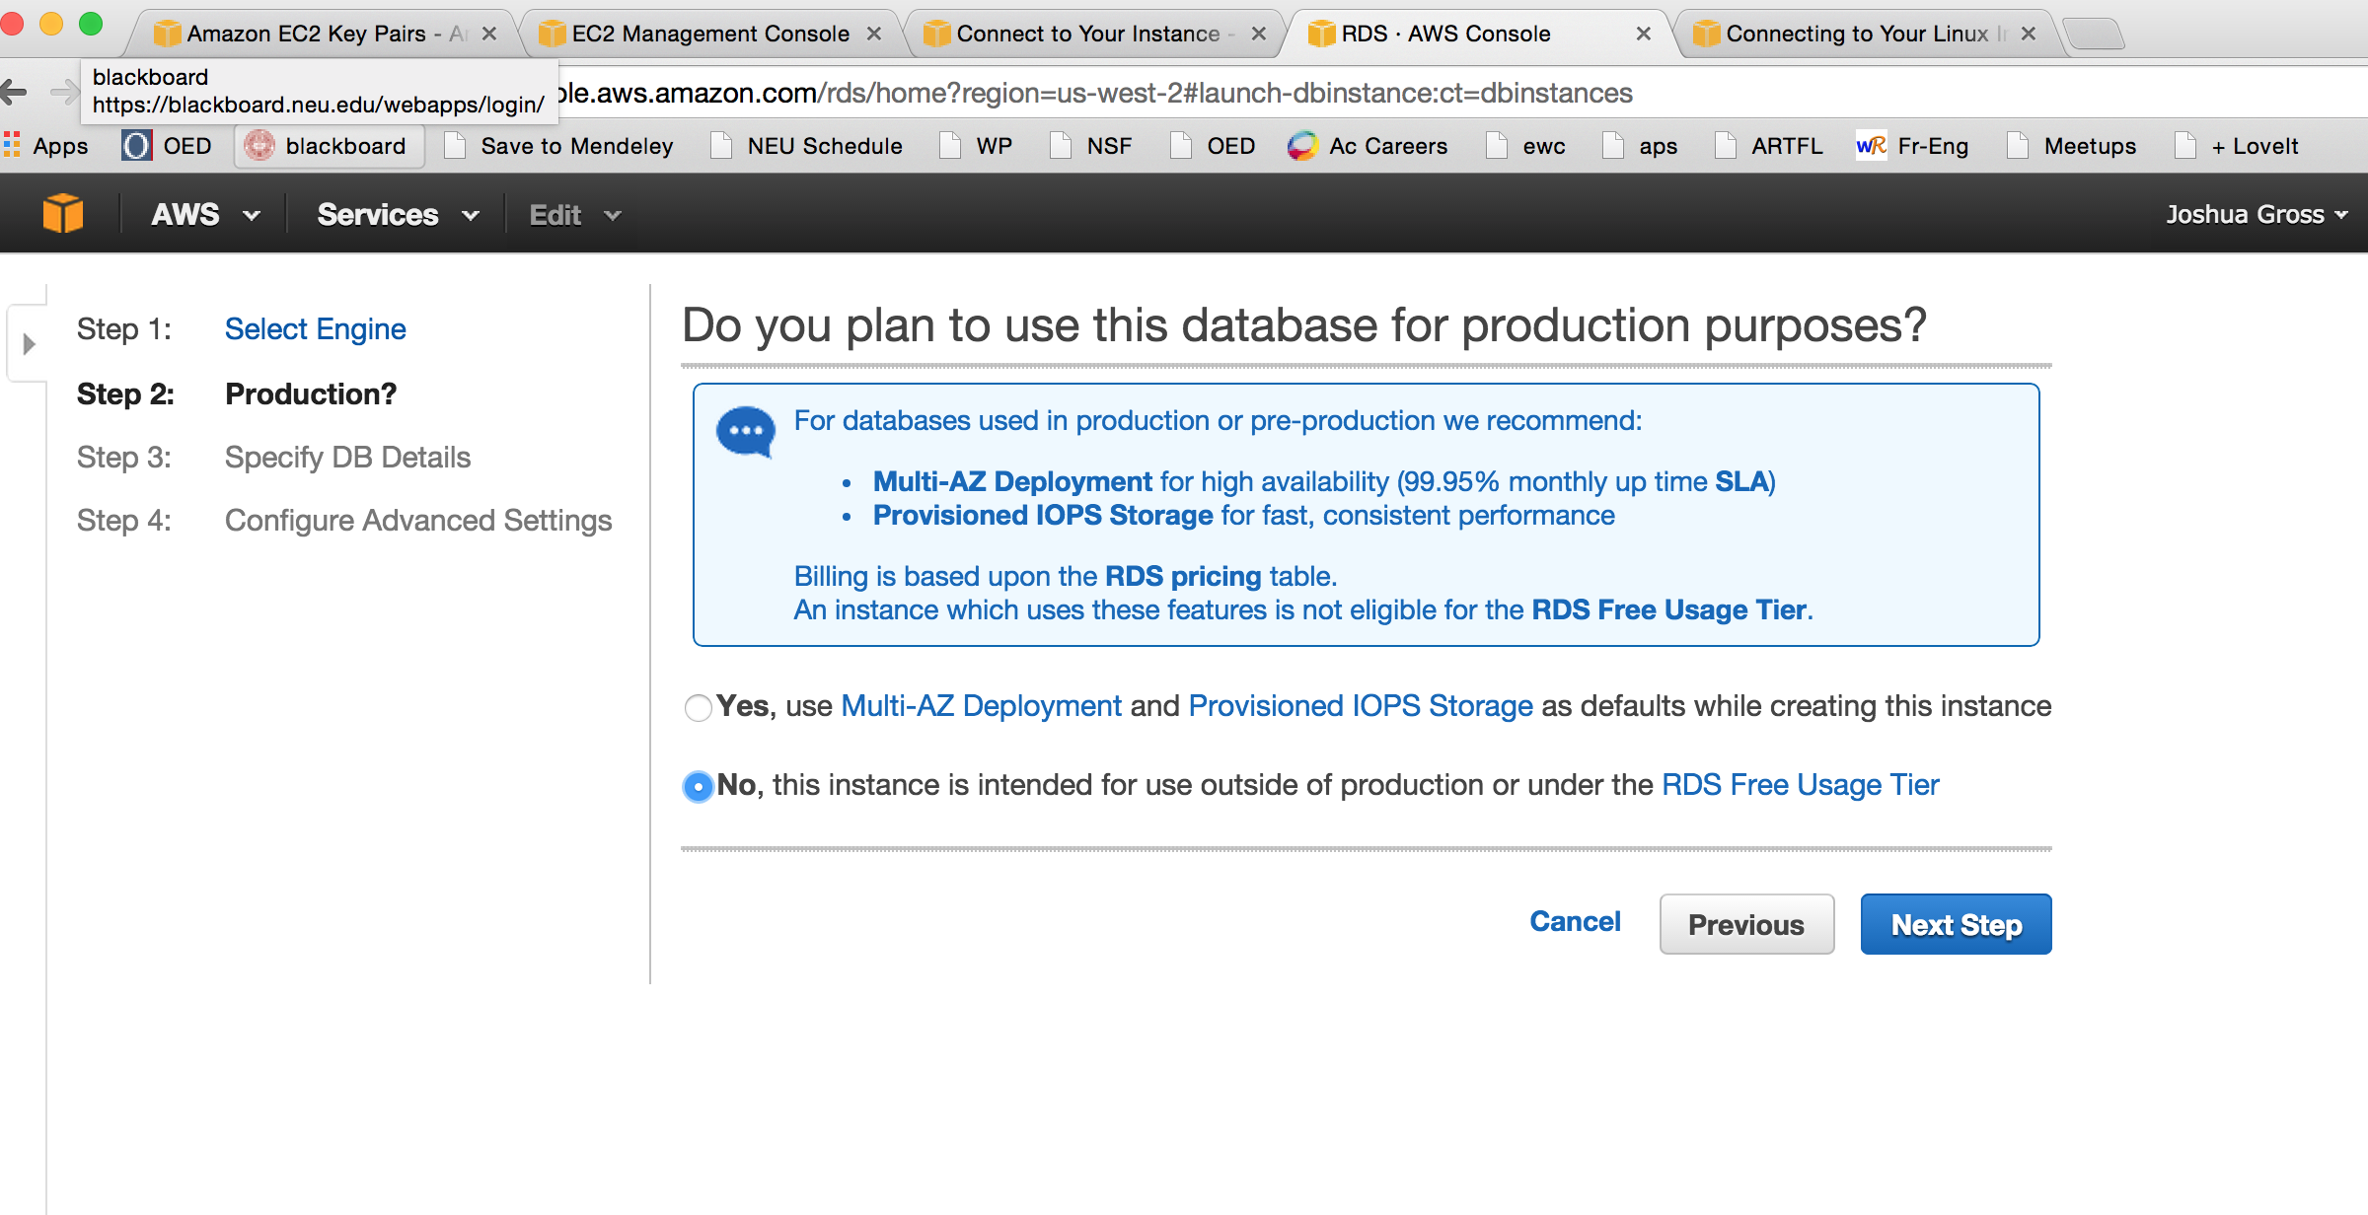

1. This is very important: to keep this database safely under free usage, you MUST select the option “No, this instance is intended for use outside of production or under the RDS Free Usage Tier”. Basically, your telling Amazon you don’t want to pay for high availability and really, really fast I/O, but don’t worry; this is how your database instance would be set up if you were building it yourself. Select the “Next Step” button once you’ve selected this radio button.

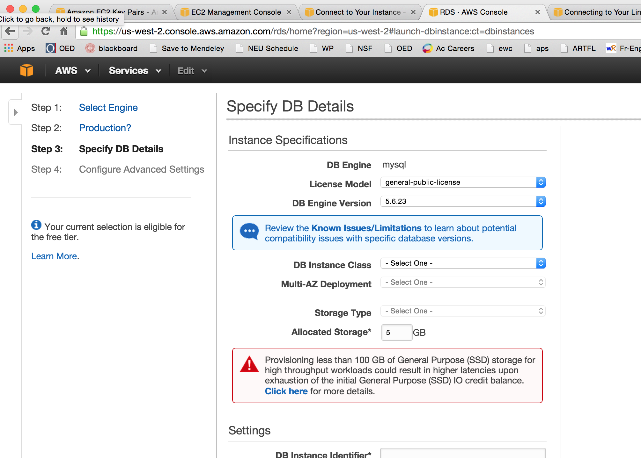

1. We need to configure the database instance. The License Model should be set to “general-public-license” (which is the only option for MySQL; they have a “bring your own license” system for Oracle’s commercial database (Oracle owns MySQL, too)). The DB Engine Version should be set to whatever the most current option is; when these instructions were written, that was 5.6.23. This is not the same version of MySQL you installed on your server instance, but they are compatible. The DB Instance Class should be set to “db.t2.micro – 1 CPU, 1 GiB RAM” (this is the free tier). Multi-AZ Deployment should be set to “No” (it’s not free and we don’t need it; it’s a neat system, though, that keeps a hot copy of your database instance in another region, so if your home region goes down your database will automatically fail over). Don’t hit “Next Step” just yet.

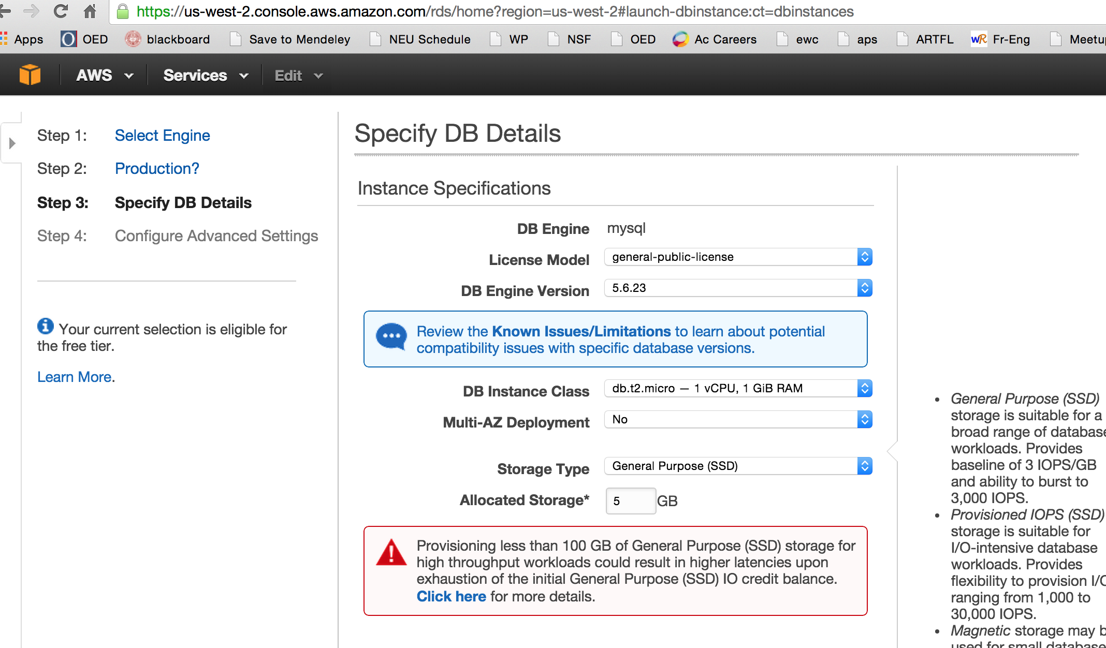

1. For the free tier, you’re allowed 20 GB of Allocated Storage (again, this is separate from the EBS storage on the server instance, and from the S3 shared storage, which we’re not using). It’s unlikely we’ll need this much space, but it’s hard to add it later, so we’ll change it now.

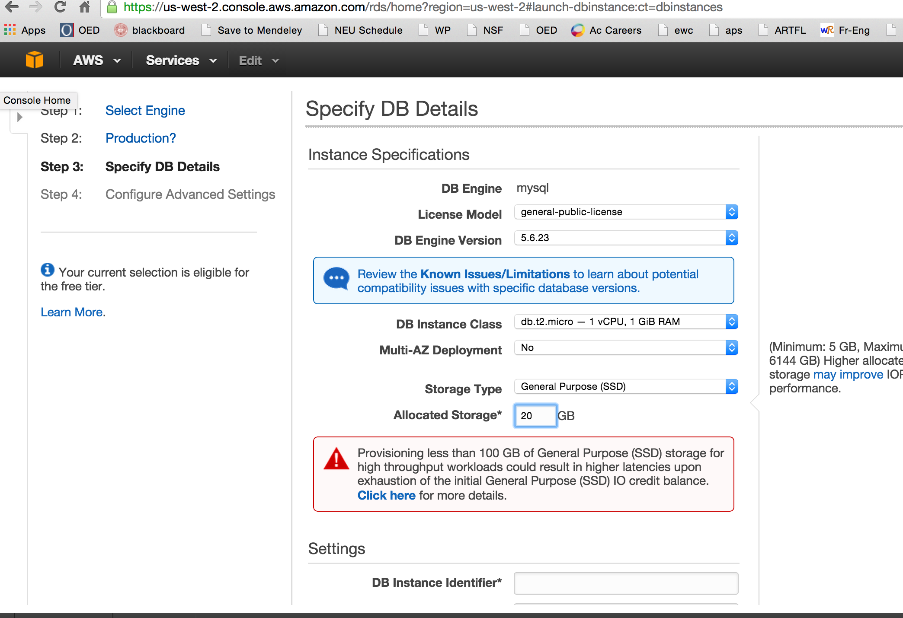

1. Now we need to set the access control for the database. There are four fields to fill in. The first is the DB Instance Identifier (do not confuse this with the name of the database, which yeah, that’s confusing, but that why I’m making this point, the DB Instance Identifier is not the same as the name of the database); this can be anything, but I would make it your name plus the initials “db”. Next is the database Master Username; in a production database, for security reasons you would almost never use this account, but we’re going to use it for convenience, so set it to your username. Set the password something you’ll remember. We can always add more accounts later. However, if you forget your Master Username and/or Password, the database is permanently inaccessible and unrecoverable. There’s no special access that your instructors have. Fill out the fields and select the “Next Step” button.

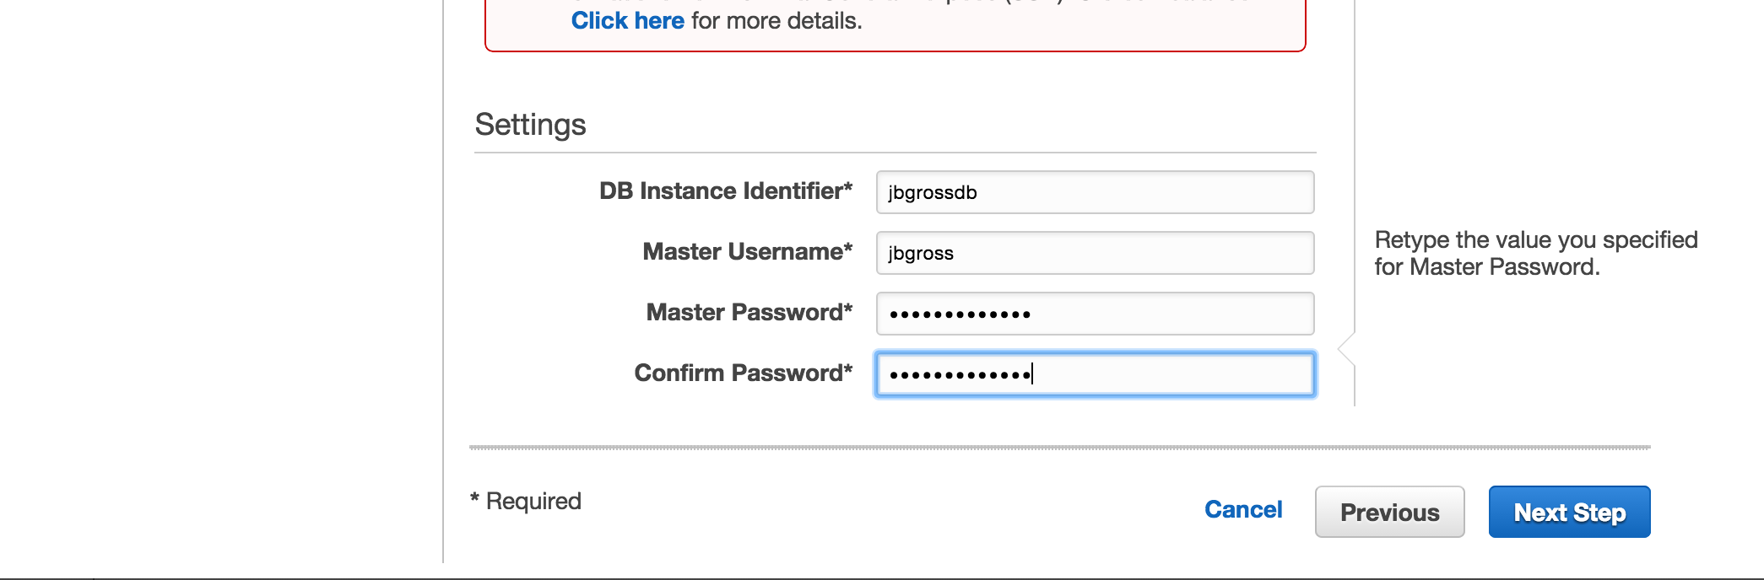

1. In the Advanced Options, we just need to select the VPC (Virtual Private Cloud) Security Group of “launch-wizard-1 (VPC)”. This is the security group we created earlier. Then select the Launch DB Instance button.

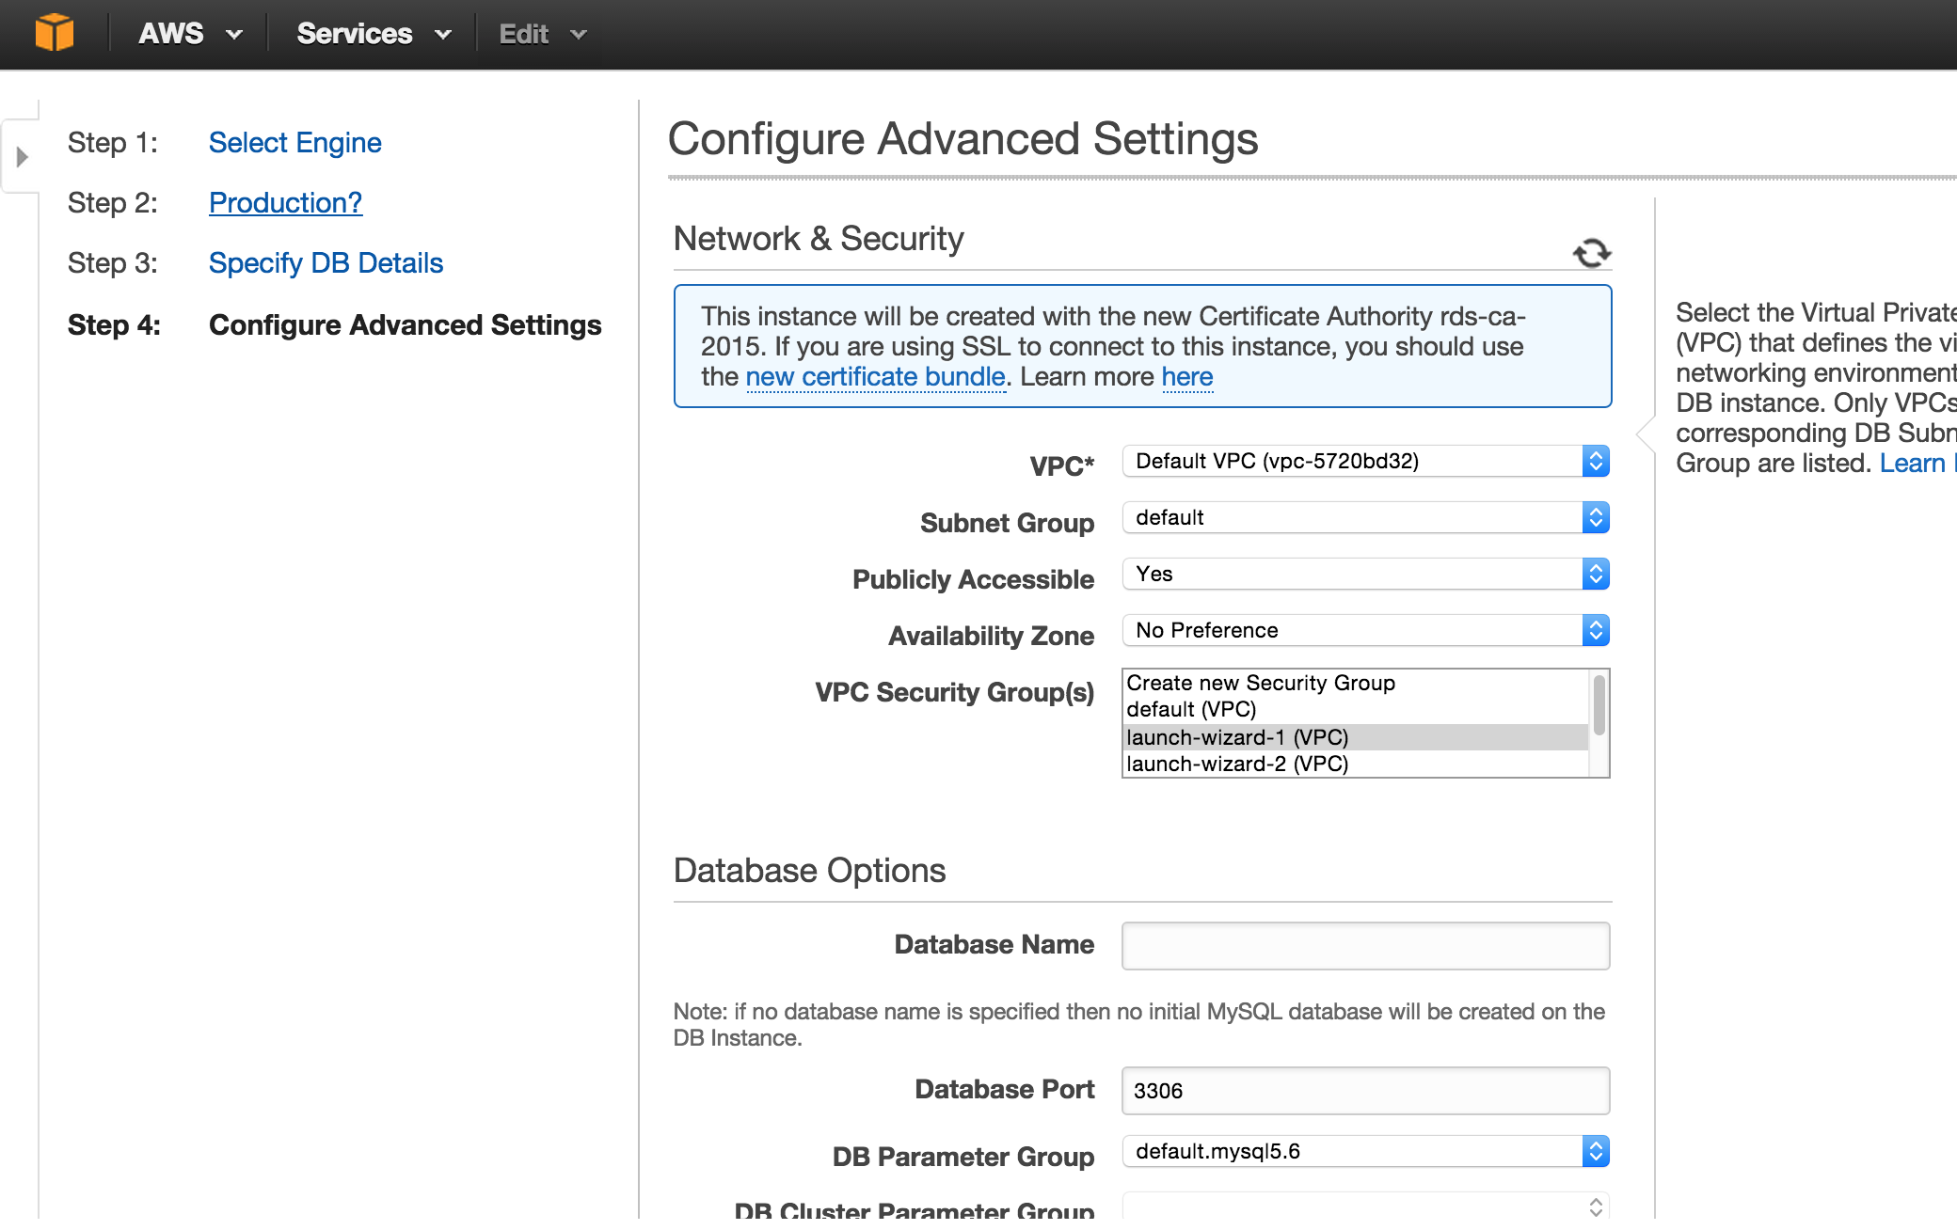

1. Select the View Your DB Instances button.



1. As with the server instance, this will take a few minutes. Select the “Show DB Instances” button. Once your database instance is available, you will note that the console is telling you that you have no access path to the database.

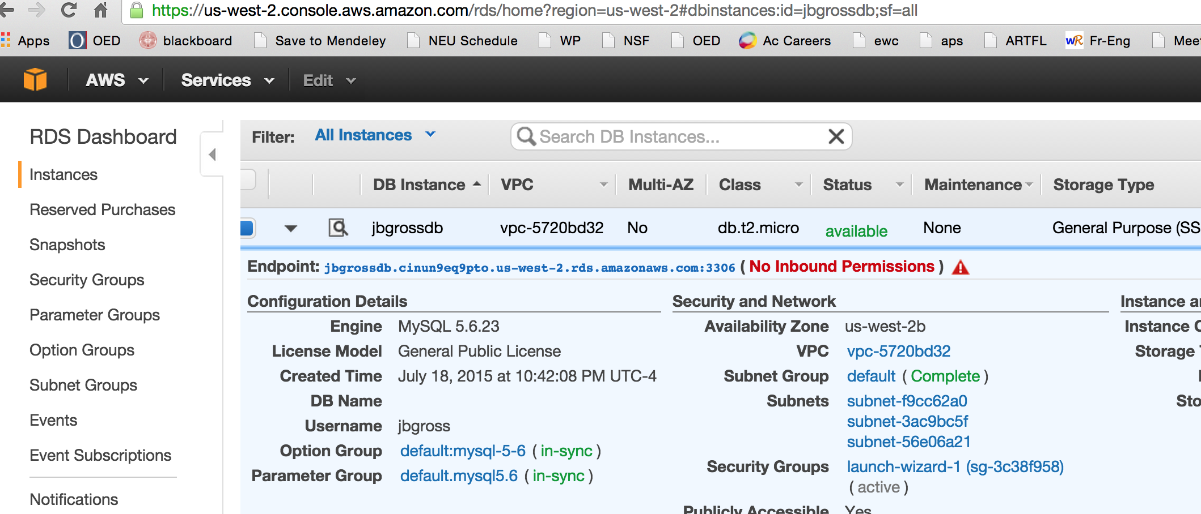

1. Hover your cursor over the red alert triangle next to the words “No Inbound Permissions”. You will see that the security policy for this VPC has no rules to allow inbound traffic. Select the “Edit Security Group” button.

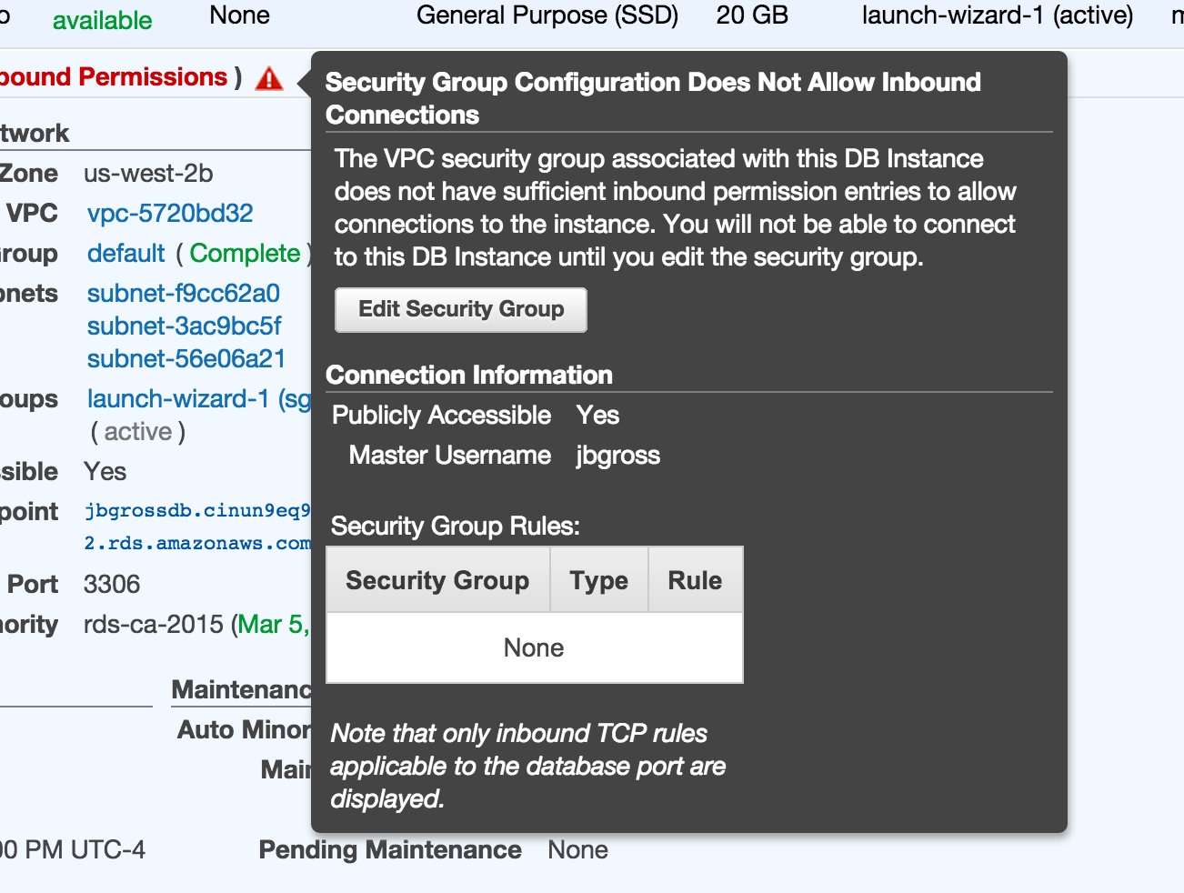

1. This will open a new tab; don’t worry, you can have multiple tabs open to different or the same parts of the console simultaneously. You will see the security group we created earlier, “launch-wizard-1”. Select its checkbox if it’s not, select the Inbound tab near the bottom, and select the Edit button.

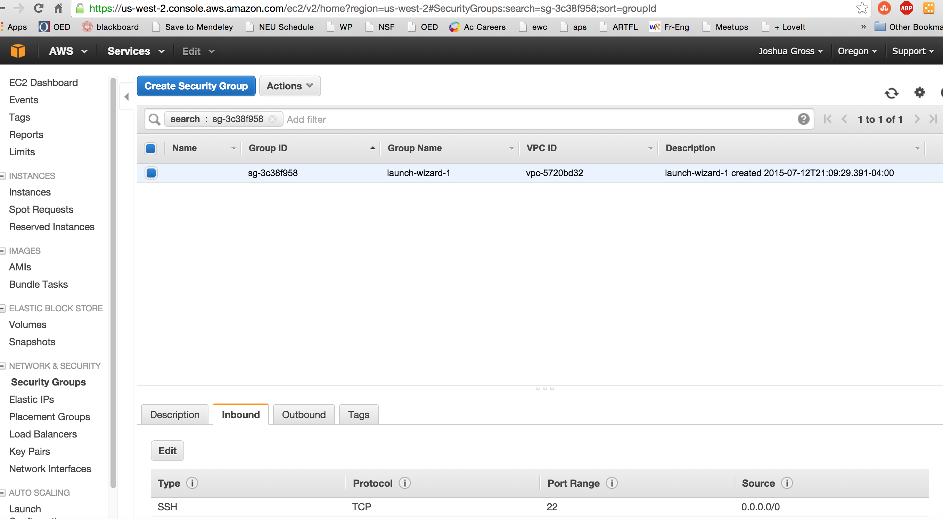

1. Select the Add Rule button, and select the type as MySQL/Aurora, the Protocol as TCP, the Port Range as 3306, the Source as Anywhere with an address of 0.0.0.0/0. Then select the Save button. Your database is now accessible from anywhere in the world; again, this is not a real-world security strategy.

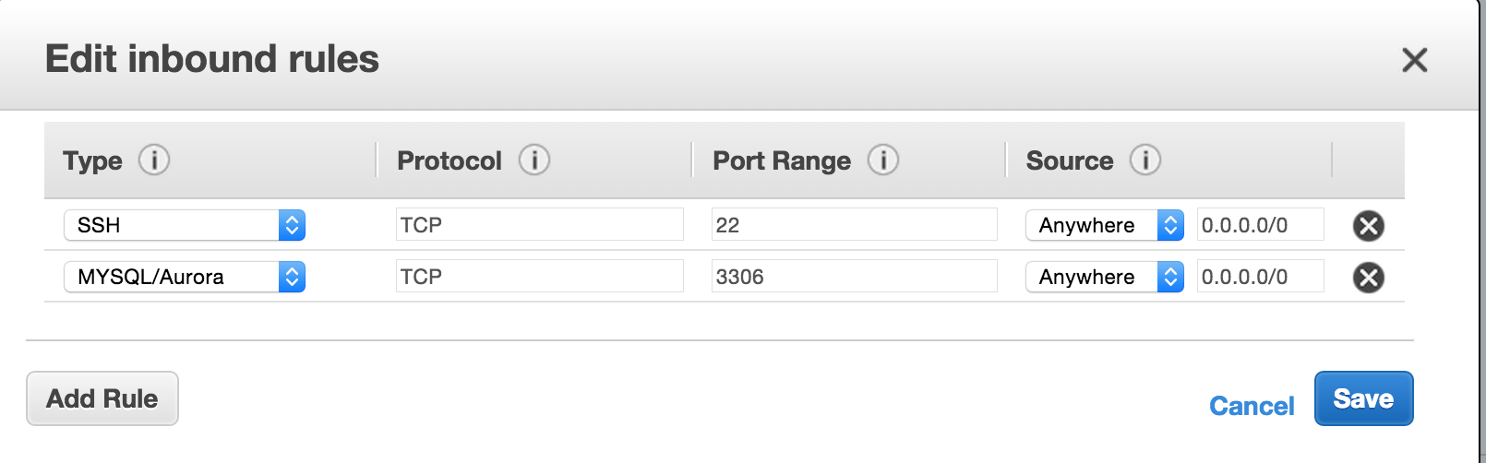

Step Five: Connecting to Your Server and Building the Databases

In order to build the databases you will be using in the course and load them with data, you will need to upload several files to your Linux server.

1. Download the database files from the course website to your personal computer

bank_db.sql

census_db.sql

resident.data

mp3_db.sql

1. Copy each of the files to your Linux server using scp (Linux/MacOS) following the instructions at <http://docs.aws.amazon.com/AWSEC2/latest/UserGuide/AccessingInstancesLinux.html> or PuttySCP (Windows command line) or WinSCP (Windows GUI tool), following the instructions at <http://docs.aws.amazon.com/AWSEC2/latest/UserGuide/putty.html>.
2. Log on to your server instance using ssh (Linux/MacOS) or Putty (Windows). Use the command “ls” to verify that the files are in your home directory.

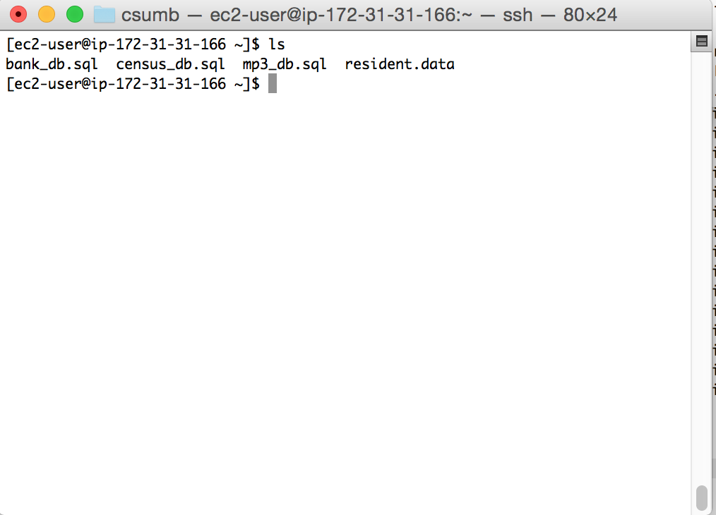

1. Connect to the database from your Linux command prompt using the command

mysql –h <dns-name>.rds.amazonaws.com –P 3306 –u <your username> -p

The name of the client software is mysql (mysqld is the server software). The –h option tells the client the hostname (DNS address) of the database instance. The –P option tells the client which port to use. The –u option lets you specify a username, and the –p option (lowercase p this time) tells the client to prompt you for a password when loggin you in.

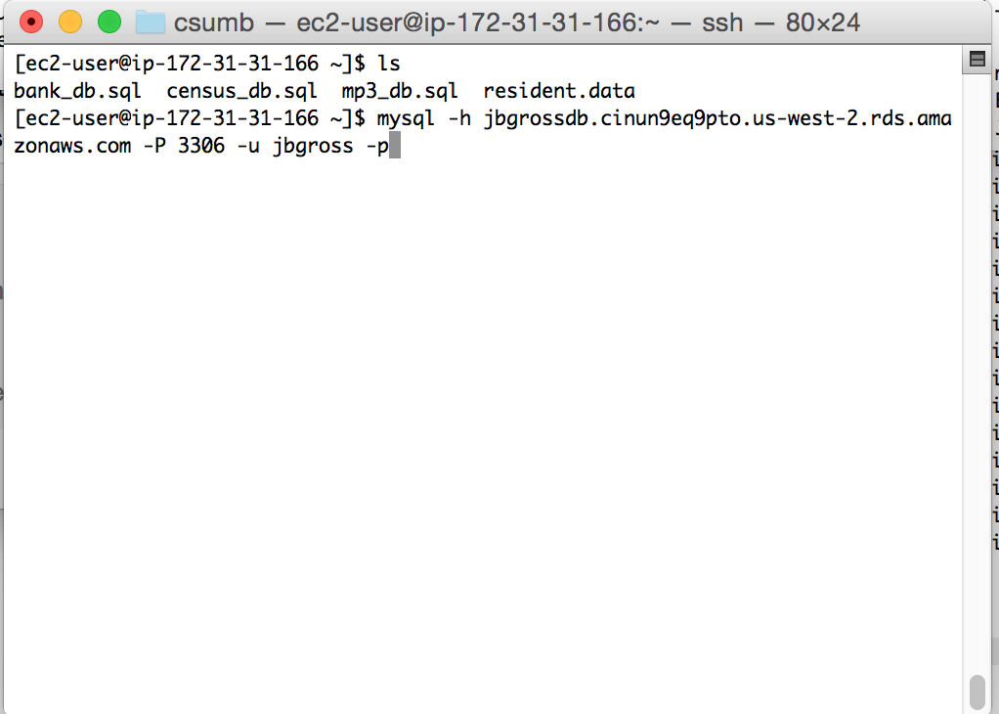

1. This will log you in to the database. From here you can access any data, as well as control security. We’re going to build the database from here.

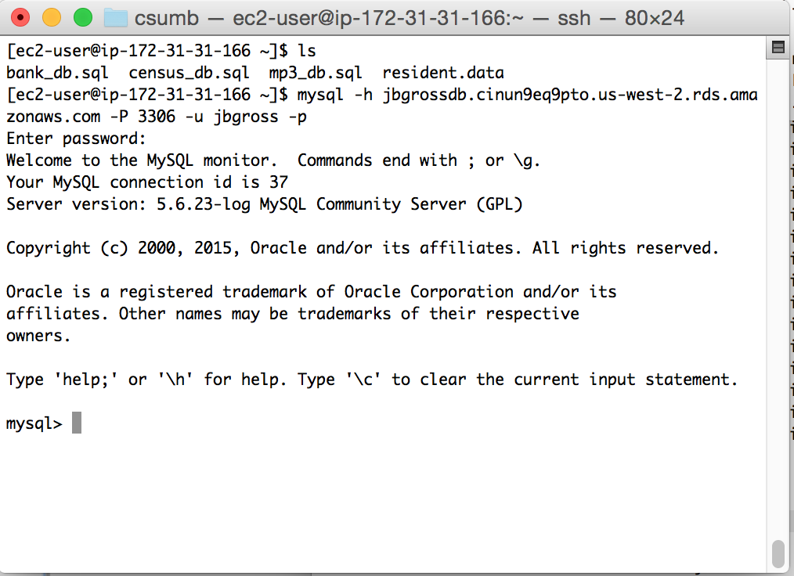

1. To build the database, enter “\. census_db.sql”. This tells MySQL to execute a local file named “census_db.sql” located in the same directory that you were in when you started the mysql client. Note that you cannot use a semicolon at the end. Press enter to build the database; it should take roughly a minute. You may get some beeps or warnings; this is because the script tears downs the database and then rebuilds, but if there’s not database to tear down, it reports errors.

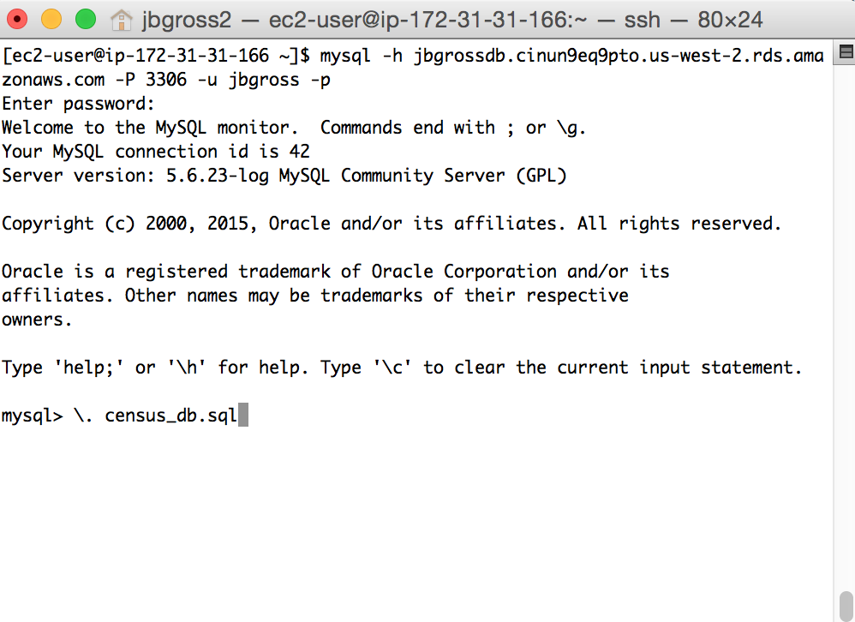

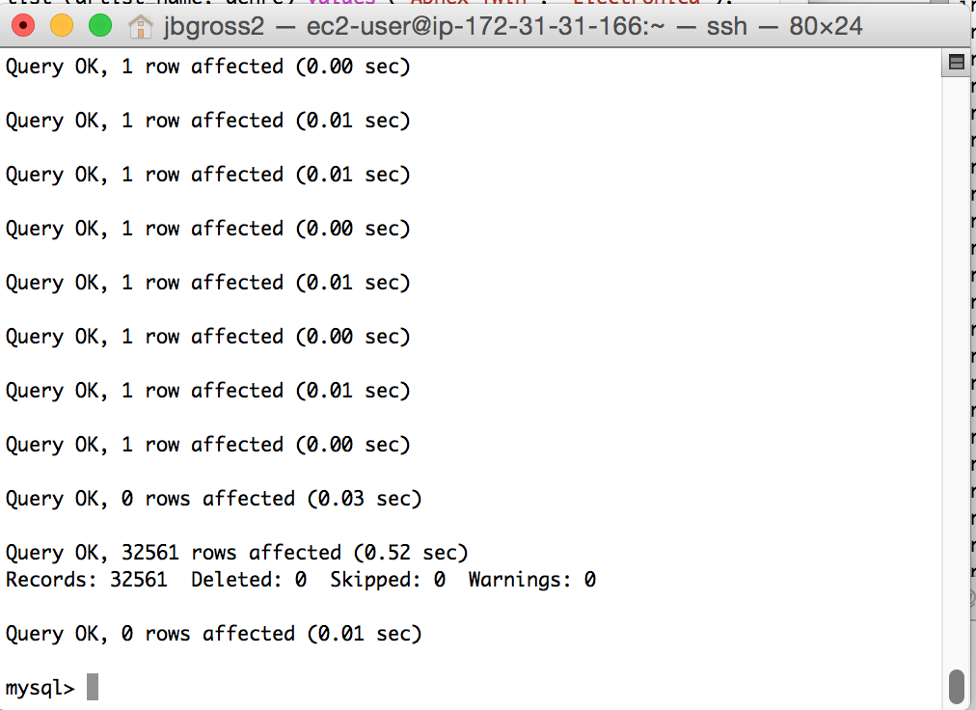

1. To verify that the database built properly, we’re going to run a select statement on a view that joins all of the tables. To select the census database, enter “use census” and press enter. Then use the following command to see the age, educational level, and occupation for each person from Yugoslavia. Don’t worry that you don’t understand the syntax of SQL yet. Note that here you *must* use a semicolon at the end of your statement.

select age, education_name, occupation_name from resident_data where native_country_name = 'Yugoslavia';

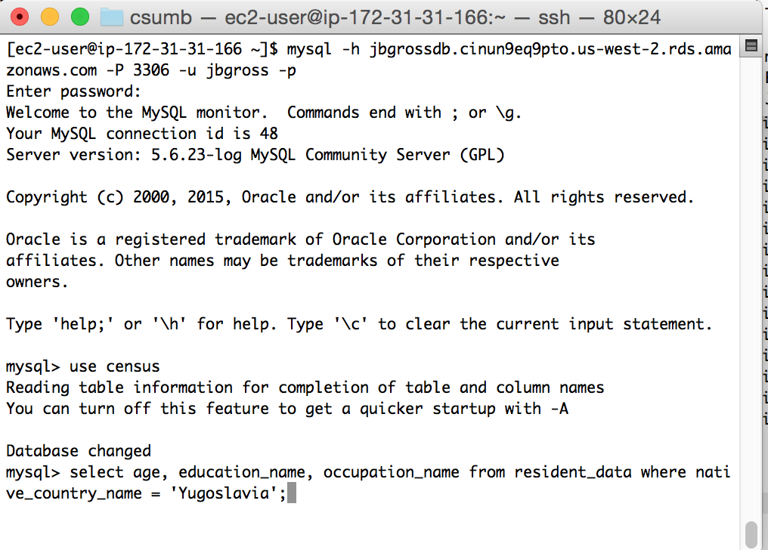

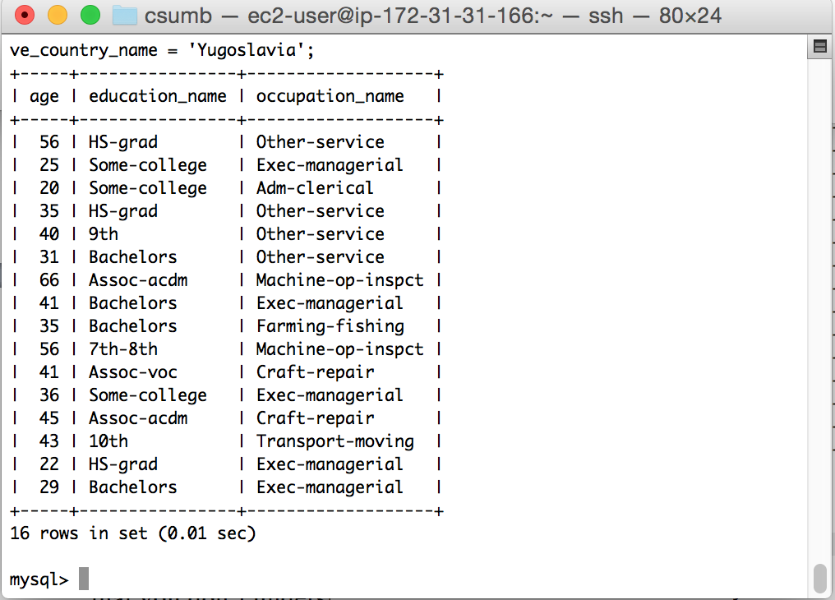

1. We will cover the rest of the databases later. To leave the database, enter “exit”. To log off from the ssh connection to your Linux instance, use “exit”.